**Application Name**

Microsoft Dynamics CRM

Application Information Document (AID)

**Document Revision History**

|  |  |  |  |  |
| --- | --- | --- | --- | --- |
| **Ver #** | **Date** | **Author** | **Reviewer** | **Comments** |
| 1.0 | 10/28/2016 | Sudheer K  Om Thute  Ghirijha  Sreeshma S  Guillermo Cardona |  |  |

*Note: Please update Doc ID, other front page details and rev. history upon usage of this template*

# Contents

Contents 2

1. Introduction 5

1.1 Business Process Overview 5

1.2 System Overview 7

1.2.1 Application Landscape 7

1.2.2 System Details 7

1.2.3 Applications in Scope 10

1.2.4 Applications out of scope 10

2. Operating Environment 10

2.1 Development Environment 10

2.1.1 Expected Capacity 10

2.1.2 Design Overview 10

2.1.3 Logical Architecture 11

2.1.4 Server specification 11

2.2 Non-Production Environment 12

2.2.1 Design Overview 12

2.2.2 Logical Architecture 12

2.2.3 Specifications 12

2.3 Production Environment 13

2.3.1 Expected Capacity 13

2.3.2 Design Overview 14

2.3.3 Logical Architecture 15

2.3.4 External Load Balancer Configuration 15

3. System Details 15

3.1 Data Model 15

3.2 Process Description 17

3.2.1 Customer Service/Enrollment 17

3.2.2 Billing Management Process 28

3.2.3 Contractor Management 31

3.2.4 Claims Management 41

3.2.5 Marketing Management 49

3.2.6 Quality Audit 52

3.2.7 Compliance Management 53

3.2.8 Denial Reasons 53

4. Build and Deployment Process 53

4.1 AWE Database and AWE Integration Deployment 53

4.1.1 TFS Location 53

4.1.2 Steps to be followed for builiding the Evolution_Staging Database 54

4.1.3 Steps to be follwed for building the Evolution_integration database 56

4.1.4 Steps to be followed for builiding the AWE Integration Project 57

4.1.5 Deployment of Database and SSIS Packages 59

4.2 AWE Scribe DTS Deployment 62

4.3 CRM 2013 deployment 67

4.4 Support Process 68

5. Test Environment 71

5.1 Testing tools 71

5.2 Integration Test Environment 71

5.2.1 Expected Capacity 71

5.2.2 Design Approach 71

5.2.3 Conceptual and Logical Architecture 72

5.2.4 Specifications 74

6. Important System Characteristics 76

6.1 Transaction Volume and Data Volume 76

6.2 Job Scheduling/Sequencing of Batch Jobs 76

6.2.1 Overview 76

6.2.2 Integrations with Third Parties 83

6.2.3 RRD Prospects into CRM 86

6.2.4 Lockbox integration 86

6.2.5 Delinquency Integration Process 86

6.2.6 Processing of Shutoffs 88

6.2.7 Integration with Dynamics AX 88

6.2.8 Auto Renewal 90

6.2.9 Problem Payment 92

7. Issues / Constraints 92

7.1 Issues 92

7.2 Suggestions 93

8. Application Operations Support 93

8.1 Production support & Maintenance 93

8.2 Production support parties with contact information 93

8.3 Production support activities 93

8.3.1 Support tasks activity description 93

8.3.2 Scope of work for Maintenance & Production Support 93

8.3.3 Support Activity Roles 93

8.3.4 Support Methodology 94

8.4 Application SLAs 94

8.4.1 SLA 94

8.4.2 Tools inventory 94

# Introduction

American Water is a public utility company operating in the United States and Canada. AW Provides the regulated services of Water, Sewer Services, fire, and irrigation water.

American Water Resources (AWR), a division of the market based division of AWE, which is a division of American Water, offers utility services by protecting homeowners against unexpected home repair costs. They offer protection programs that protects homeowners where insurance policies don’t.

Microsoft’s Dynamics CRM (MSCRM) is used to effectively handle customer as well as contractor related information and their various activities in CRM. Important domains are:

* Sales and Marketing – It includes process of capturing new prospects and maintaining customer and contractor information.
* Service – It includes process of resolving problems faced by customer and complaints if any
* Billing and Payment – It includes handling customer payment and maintaining its details in MS CRM



In this document, we will explain and include all of the Important Business Processes in MSCRM. They include:

* Contractor management
* Customer management
* Claims
* Enrollment and Payment Authorization
* Integration to third party systems
* Marketing
* Billing
* Quality Assurance and Compliance

We will detail all of the supporting process for the main process listed above as well.

## Business Process Overview

Below are the modules implemented for American Water CRM

Customers are reached out via the marketing team with an invitation to enroll for services provided by AWE. If the customer is interested, he/she will enroll by either calling the call center managed by the customer service team, via mail responding to a postcard-based campaign, or by sending an enrollment form along with a check to a pre-defined address (AWE’s bank).

The customer would then call the customer service team if he/she has an issue that needs to be fixed under the program that they are enrolled in. This process is handled by the Claims process. Claims are serviced by independent contractors.

Billing handles payments, delinquencies, and any other issues with enrollments or the payments to contractors

Contractor Management handles the contractors, how they are ranked in the system, and any management processed related to them such as sign up, deactivation, etc.

All claims and enrollments are audited by the QA team via their QA Audit process.

The compliance team uses the application to monitor insurance license compliance for specific agents in the company that sell certain programs in certain states.

Details on these processes will be covered on section 3.2 of this document.

## System Overview

### Application Landscape

Microsoft Dynamics CRM 2013 SP1. The implementation has multiple integrations that use Scribe and SSIS to communicate between CRM and the other parties. These integrations include:

* Integration to SAP for customer, billing, and enrollment management
* Integration to Dynamics AX for customer, contractor, billing, and enrollment management
* Integration to RRDonnelly for marketing and enrollment management
* Integration to Third parties (Orlando, Nashville, etc.) for enrollment, customer, and billing management
* Integration to ETS for payment processing
* Integration with a CTI system for automatic call record selection

Dynamics CRM contains quite a bit of custom code in the form of plugins and JSCRIPT embedded in several web resources. In addition, the SiteMap was customized to repurpose modules, and to add additional modules to meet the needs of the client. More details are covered in the corresponding section of the business process for which the customization was created.

### System Details

***High-Level Architecture of the application***

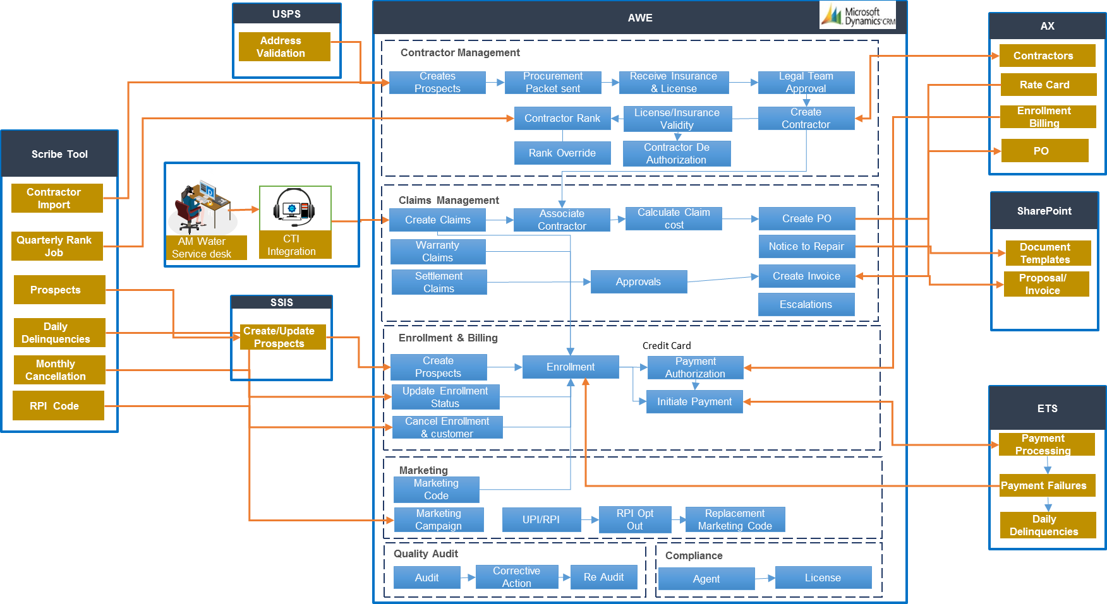

***Server and Database Inventory***

|  |  |  |  |  |  |  |  |
| --- | --- | --- | --- | --- | --- | --- | --- |
| **Hostname** | **Sub-system** | **Environment** | **Databases** | **Database Server** | **Environment 2** | **Databases 2** | **Database Server 2** |
| **evocrmcnv02** | CRM | Data Conversion | Conversion_MSCRM | EvoCrmCnv01 |  |  |  |
| MSCRM_config |  |  |  |
| **evocrmcnv03** | CRM | Data Conversion | Conversion_MSCRM | EvoCrmCnv01 |  |  |  |
| MSCRM_config |  |  |  |
| **evocrmcnv04** | CRM | Data Conversion | Conversion_MSCRM | EvoCrmCnv01 |  |  |  |
| MSCRM_config |  |  |  |
| **evocrmcnv05** | CRM | Data Conversion | Conversion_MSCRM | EvoCrmCnv01 |  |  |  |
| MSCRM_config |  |  |  |
| **evocrmdev02** | CRM | Data Conversion |  |  |  |  |  |
| **testi-crm01** | Scribe | Data Conversion | ScribeInternal_Cnv | localhost |  |  |  |
| **evoaxcnv05** | SQL Server | Data Conversion |  |  |  |  |  |
| **evocrmcnv01** | SQL Server | Data Conversion | Conversion_MSCRM | localhost |  |  |  |
| DefectResolution_MSCRM |  |  |  |
| MSCRM_config |  |  |  |
| Sandbox_MSCRM |  |  |  |
| ReportServer |  |  |  |
| ReportServerTempDB |  |  |  |
| **evocrmdev03** | CRM | Developer Workstation | Evolution_MSCRM | localhost |  |  |  |
| MSCRM_Config |  |  |  |
| **evocrmdev04** | CRM | Developer Workstation | Evolution_MSCRM | localhost |  |  |  |
| MSCRM_Config |  |  |  |
| **evocrmdev05** | CRM | Developer Workstation | Evolution_MSCRM | localhost |  |  |  |
| MSCRM_Config |  |  |  |
| **evocrmdev06** | CRM | Developer Workstation | Evolution_MSCRM | localhost |  |  |  |
| MSCRM_Config |  |  |  |
| **evocrmdev07** | CRM | Developer Workstation | Evolution_MSCRM | localhost |  |  |  |
| MSCRM_Config |  |  |  |
| **evocrmdev08** | CRM | Developer Workstation | Evolution_MSCRM | localhost |  |  |  |
| MSCRM_Config |  |  |  |
| **evocrmdev09** | CRM | Developer Workstation | Evolution_MSCRM | localhost |  |  |  |
| MSCRM_Config |  |  |  |
| **evocrmdev10** | CRM | Developer Workstation | Evolution_MSCRM | localhost |  |  |  |
| MSCRM_Config |  |  |  |
| **ax-sql-pp-01** | SQL Server | Development |  |  | Training |  |  |
| **ame001-tfsbld01** | TFS | Development |  | localhost |  |  |  |
| **ame001-tfssc01** | TFS | Development | Tfs_Configuration | localhost |  |  |  |
| Tfs_DefaultCollection |  |  |  |
| Tfs_Evolution |  |  |  |
| Tfs_Warehouse |  |  |  |
| ReportServer |  |  |  |
| ReportServerTempDB |  |  |  |
| **evocrmdev01** | CRM | Development (Integration) | Evolution_MSCRM | localhost |  |  |  |
|  |  |  | MSCRM_Config |  |  |  |  |
| **evoscribedev01** | Scribe | Development (Integration) | ScribeInternal_Dev | localhost |  |  |  |
| **evocrmfuntst01** | CRM | Functional Unit Test | Evolution_MSCRM | localhost |  |  |  |
|  |  |  | MSCRM_Config |  |  |  |  |
| **testi-crm-fe** | CRM | Test | Evolution_MSCRM | TESTI-SQL3 | Test | ReportServer | TESTI-SQL5 |
|  |  |  | MSCROM_config |  |  |  |  |
| **testi-crm-fe2** | CRM | Test | Evolution_MSCRM | TESTI-SQL3 | Test | ReportServer | TESTI-SQL5 |
|  |  |  | MSCROM_config |  |  |  |  |
| **evoscribenp01** | Scribe | Test | ScribeInternal_Np | TESTI-SQL5 |  |  |  |
| **testi-sql** | SQL Server | Test |  |  |  |  |  |
| **testi-sql2** | SQL Server | Test | DAX |  |  |  |  |
| DAX_model |  |  |  |  |
| **testi-sql3** | SQL Server | Test | Evolution_MSCRM |  |  |  |  |
| MSCRM_Config |  |  |  |  |
| **testi-sql4** | SQL Server | Test | ReportServer |  |  |  |  |
| MR |  |  |  |  |
| MR_DM |  |  |  |  |
| **testi-sql5** | SQL Server | Test | ReportServer |  |  |  |  |
| ScribeInternal_Np |  |  |  |  |
| **train-crm01** | CRM | Training | Evolution_MSCRM | AX-SQL-PP-01\TrainCRM | Training | ReportServer | AX-SQL-PP-01 |
| MSCRM_Config |  | SSRS instance: SSRS_TrainCRM |
| **train-scribe01** | Scribe | Training | ScribeInternal_Trn | AX-SQL-PP-01 |  |  |  |
| **evocrmcnvlb** | CRM |  |  |  |  |  |  |

### Applications in Scope

The following applications are in scope:

* Dynamics CRM 2013
* Scribe
* SSIS (as it relates to the integrations. Optimizing SQL, installation, or upgrades to SQL is out of scope)

### Applications out of scope

The following applications are out of scope:

* Dynamics AX
* SharePoint (Infosys supports the integration to it, but not the application itself including mail merge configuration and troubleshooting from the SharePoint side)
* ETS (the interface between CRM and ETS is in Scope)
* Marketo

# Operating Environment

NOTE: The details in this section has been updated based on the document Artifact 6_TA355 AWE Technical Architecture Design.docx

## Development Environment

### Expected Capacity

The development environment shall support:

* Dynamics CRM development team consisting of a total of 6 on-shore and off-shore developers.

### Design Overview

* One VM per developer
  + Number of CRM developers: 10
* On each developer VM:
  + Developers will be members of the local administrator group on developer VM’s.
  + Developers will hold the sysadmin role on the local SQL Server.
* Remote access:
  + Login to XenDesktop, then RDP to assigned developer VM
* Should a developer VM be rendered unstable or unusable, it will be restored from the applicable CRM master VM image.
* Team Foundation Server for code lifecycle management.
* Dynamics CRM releases will be deployed to a master build development organization. From there, a master build (or bundle) will be created and shared with AWE. Infosys will not deploy to Test or Production. AWE has that responsibility.

### Logical Architecture



Figure : Non-production and development Environments

### Server specification

|  |  |  |  |  |
| --- | --- | --- | --- | --- |
| **Server Role** | **Qty** | **Typical Hardware Resources** | | **OS & Application Software** |
| **Dynamics CRM Developer VM**  **(EvoCrmDev01-10)** | 10 | * 2 vCPU * 8Gb vRAM (Dynamic Memory) * 60Gb system volume * 100Gb data volume | * Dynamics CRM 2013 SP1 developer install * Windows Server 2012 * Internet Information Services 8 * SQL Server 2012 SP1 * Reporting Services * Visual Studio 2013 * Office 2010 | |
| **Development Integration Server**  **(EvoScribeDev01)** | 1 | * 2 vCPU * 8Gb vRAM * 50Gb system volume * 100Gb data volume | * Windows Server 2012 * Scribe Adapter for Dynamics * SQL Server 2012 SP1 | |
| **TFS Server** |  | * Existing | * Visual Studio Team Foundation Server 2013 * SQL Server 2012 SP1 * TFS databases * SSAS & SSRS databases for TFS analytics and reports | |
| **Build/Staging Server** | 1 | * 4 vCPU * 8Gb vRAM * 60Gb system volume * 100Gb data volume | * Windows Server 2012 | |
| **Network File Share for developers** |  | * Existing | * “S:\Proj Evo” in Citrix XenApp desktop environment | |

Table : Development Environment - Infrastructure Specification

The TFS server already exists in American Water’s development environment. This server is expected to be shared with other American Water projects in the future.

## Non-Production Environment

The non-production environments shall support up to 25 users. It is not expected that all of these users will be active in all environments concurrently.

### Design Overview

* Conference Room Pilot
  + Functional prototyping for CRM
* Functional Test
  + Pre-integration testing, data conversion testing, etc.

In order to minimize costs, the follow approaches are considered:

1. Consolidate all Pre-Production databases and Reporting & Analysis services on to one SQL Server if there is minimal overlap in the use of the different Pre-Production environments.
2. Repurpose DataConversion for Training when the data conversion tasks have been completed.
3. Co-locate Project and MasterData environments on one VM (these environments typically have low load)

Remote access to Non-Production environments:

* Users login to the appropriate XenApp Desktop.
* For CRM, users load the URL for the appropriate CRM pre-production environment.

### Logical Architecture

See section 2.1.3

### Specifications

|  |  |  |  |
| --- | --- | --- | --- |
| **Server Role** | **Qty** | **Typical Hardware Resources** | **OS & Application Software** |
| **Non-Production Environments**   * **DataConversion 2 (CRM)** * **Conf Room Pilot (CRM)** | 8 | * 4 vCPU * 12Gb vRAM (Dynamic RAM) * 100Gb system volume * 100Gb data volume | * Windows Server 2012 * Dynamics CRM 2013 SP1 * Management Reporter 2012 * Visual Studio components as needed * ISV software (out of Avanade scope): * Atlas XL client * CCH Sales Tax Office client & server * ImageNow client |
| **Non-Production Functional Test Environments**   * **Functional Test 2 (CRM)** | 2 | * 4 vCPU * 12Gb vRAM (Dynamic RAM) * 100Gb system volume * 100Gb data volume | * Windows Server 2012 * Dynamics CRM 2013 SP1 * Management Reporter 2012 * Test Manager * Visual Studio components as needed * ISV software (out of Avanade scope): * Atlas XL client * CCH Sales Tax Office client & server * ImageNow client |
| **Non-Production Integration Server** | 1 | * 2 vCPU * 8Gb vRAM * 50Gb system volume * 100Gb data volume | * Windows Server 2012 * Scribe Adapter for Dynamics |
| **Non-Production SQL Database Server** | 1 | * 4 vCPU * 32Gb vRAM * 100Gb system volume * 100Gb database volume (allow for future expansion) * 50Gb volume for TEMPDB * 200Gb for compressed database backups | * Windows Server 2012 * SQL Server 2012 SP1 * CRM databases |
| **Network File Share** |  | * Existing | * “S:\Proj Evo” in Citrix XenApp Desktop environment |

Table : Non-Production Environment - Infrastructure Speficiations

## Production Environment

### Expected Capacity

#### Users

CRM users: ~180 users in 2 shifts @ 80% concurrency

#### Interfaces

* AP260 AWE System Integration Strategy will contain an inventory of the Dynamics CRM and external third party interfaces.
* Current estimates of the transaction volume for the interfaces are given in the table below.

|  |  |  |  |
| --- | --- | --- | --- |
| **ID** | **Description** | **ICRM** | **Estimated Volume** |
| **INT001** | New Customer | ICRM30 | 22,000 per month |
| **INT002** | Update Customer | ICRM40 | 100 per day |
| **INT003** | New Enrollment | ICRM31 | 103,000 per month |
| **INT005** | Refund Request | ICRM34 | 10,000 per month |
| **INT006** | Update Enrollment | ICRM41 | 2,000 per day |
| **INT008** | Cancellation to AX | ICRM28 | 10,000 per month |
| **INT011** | Cancellation Request | ICRM54 | 10,000 per month |
| **INT012** | Payments |  | Web service |
| **INT015** | Claim to PO | ICRM7 | 4,200 per month |
| **INT016** | Update Claim | ICRM9 | 4,200 per month |
| **INT017** | Finalize PO | ICRM8 | 4,200 per month |
| **INT018** | Settlement | ICRM11 | 25 per day |
| **INT020** | Service Fee | ICRM10 | 4,200 per month |
| **INT021** | Invoice Paid | ICRM13 | 4,200 per month |
| **INT023** | New Contractor | ICRM14 | 30 per day |
| **INT024** | Update Contractor | ICRM15 | 100 per day |
| **INT025** | Approve Contractor | ICRM12 | 30 per day |
| **INT026** | Approve Update |  | 100 per day |
| **INT028** | Delinquency | ICRM2 | Part of INT011 |
| **INT029** | Payment Update | ICRM1 | Web service |

Table : Estimated Transaction Volumes for Interfaces

### Design Overview

The design approach for the Production environment is driven by the current AWE server license counts:

* Dynamics CRM Server: 2 (2 additional servers pending)
* Scribe for Dynamics: 1 (1 additional server pending)

CRM application servers:

* All CRM roles will be installed on the CRM farm.
* Windows network load balancing will be deployed to support CRM user traffic.

SQL database servers:

* SQL Server 3: Dynamics CRM databases.
* SQL Server 5: Dynamics CRM SSRS & SSAS

Load balancing:

* The existing Citrix NetScaler hardware load balancer infrastructure at PCI will be used for:
  + CRM server farm

High availability features:

* It is assumed that the underlying Hyper-V server platforms will have adequate high availability features to ensure either uninterrupted operations or automated failover (e.g. Hyper-V failover clustering) due to the failure of a physical server (N+1 physical infrastructure).

### Logical Architecture



Figure : Production Environment - Conceptual Infrastructure

### External Load Balancer Configuration

CRM front end:

* VIP: AME001-CRM-LB
* Servers: AME001-CRM01, AME001-CRM0

# System Details

## Data Model

Level Zero Data Flow (Context) Diagram

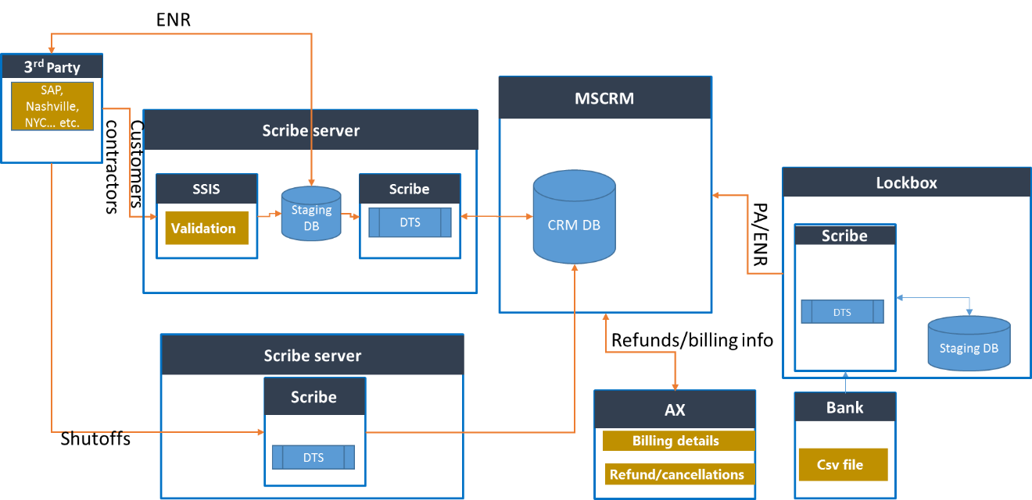

Figure : Data flow diagram between CRM and other systems

**Third party to CRM**

The customers and prospects are moved from third party databases to CRM. The third party sends the files to AWE and that file is sent to SSIS. SSIS does the validation and puts the data into staging DB. Scribe picks the data from staging database and sends it to CRM database.

Shutoffs and delinquencies are also moved from third party to CRM. Third party sends the list of cancellation customers, shutoffs, and delinquencies to AWE and that file is placed in a folder. Then Scribe moves the data to CRM.

**CRM to Third party**

The enrollments created in CRM system are moved to third party through Scribe and copied to staging request table and to a text file. This text file is picked by third party and they do their processing and sends back a response file. The response file data is copied to staging response table. The data in request table and response table are compared and status of enrollments are updated with status accordingly.

**Lock Box**

Customers can send their enrollments through via mail, which is then processed by AWR’s bank. The bank collects them and add the details to a csv file and gives it to AWR. Scribe copies it to staging table and a stored procedure is used to compare the incoming data with CRM data. Enrollments, Payment authorization or problem enrollment records are created according to the incoming data. Scribe then moves the data to CRM.

**AX to CRM**

Rate cards are sent to AX to CRM. The Refund amount, when requested by CRM is sent through AX web services to CRM. Delinquencies are also sent to CRM.

**CRM to AX**

The adjustment/refunds and cancelled enrollments are sent to AX for refund process. Contractor information is also sent from CRM to AX.

## Process Description

### Customer Service/Enrollment

The Customer Service team is responsible for the management of customers as well as managing and creating enrollments. Below is a diagram from a very high level of how the enrollment process looks like.

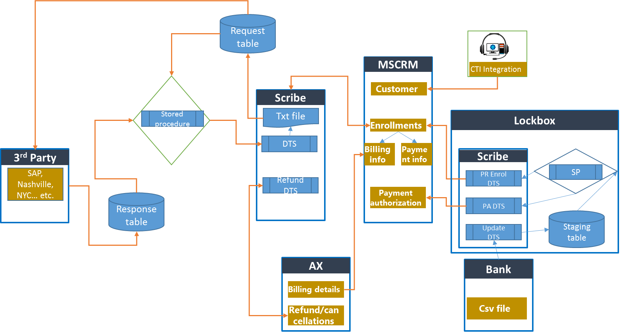

Figure : High Level View of the Customer Service Process

#### Customer/Prospect Creation

Customers are added as prospect customer into the MSCRM application from Third Party systems or from lists created by RR Donnelly. They can also be added manually from callers calling to enroll or from mail replies.

##### Imports from Third Parties

AWE receives prospects from:

* Nashville
* NYC
* Orlando

Details about this are covered in the ***Integrations with Third Parties*** section of this document.

##### Imports from RR Donnelly

AWE gets prospects from RR Donnelly (RRD). Details about this is discussed in the ***RR Donnelly*** section of the ***Marketing Management*** section of this document. Technical details on this are covered in the ***RRD Prospects into CRM*** section of this document.

##### Imports from American Water Company Customers

AWE can also get prospects from SAP from the American Water customers. Details about this are covered in the ***Integrations with Third Parties*** section of this document.

#### Enrollment creation

Enrollments are created in one of three ways:

* From the Dynamics CRM UI
* From the Lock Box file that comes from the bank via integration
* From third parties via integration

##### Enrollment creation using the Dynamics CRM UI

Customers would call a number that either gets routed to the call center in Alton, IL, or a third party company. Both have access to CRM, but only the Alton, IL users have access to the CTI Integration.

When customer calls AW service desk and requests to enroll, the CTI integration does a search against the CRM database using the phone number. If the record is found, the customer record will pop up. The user then verifies the customer information. If the customer record is not found, then a search window will open up giving the user the ability to search the record using different filters.

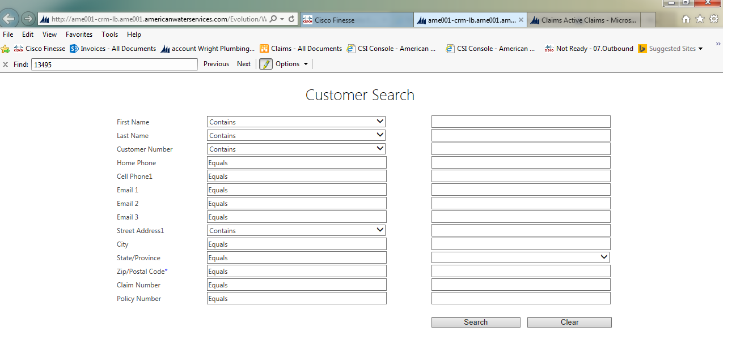

Figure : Customer Search page from CTI integration

From the customer record, the user creates enrollment record by following the process flow on the business process form of the “Residential Customer” form. The user proceeds to change the stage to the “Enroll” stage which triggers the system to create a new enrollment and present the new enrollment form.

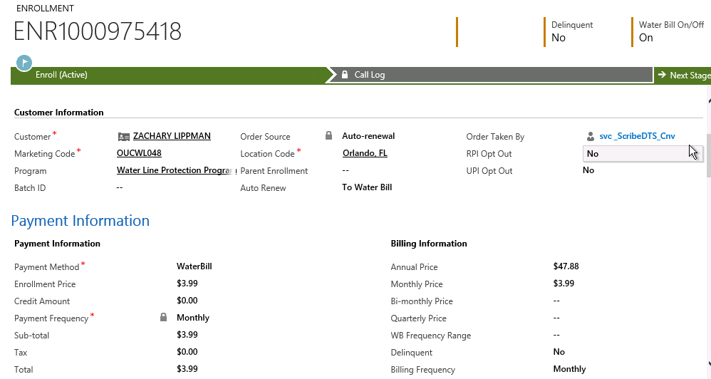

Figure : Enrollment Form in Dynamics CRM

Customer information is auto populated onto the enrollment record.

The location code at the customer record will determine which marketing codes the user can select for the enrollment. The marketing code, among other things, determines the pricing, program, and fees (Marketing Codes will be covered in the *Marketing Management* section of this document). User selects the marketing code and the Program is auto populated, along with the billing information.

Payment type will vary depending on the location code of the customer. If a customer has a location code where the *Water Bill* option is set to “Water Bill Only”, the payment for the enrollment can only be “Water Bill”. Otherwise, the payment type can be set to Credit Card, Check, eCheck, or ACH. Once the payment is selected, the user selects the payment frequency. At this point, the *Enrollment Price* gets calculated based on frequency. Tax gets calculated via web service that is connected to a third party application (called CCH).

Plugin auto calculates eligible date and end date, on save. Eligible date is a month after enroll date and end date is a year after eligible date.

For credit card payments, ACH, or eCheck, the user would then proceed to create a payment authorization. This is would be covered in more detail in the ***Payment Authorization*** section of this document.

Once the enrollments are completed, they are sent to either AX or third-parties, depending on the location code and payment type. For water bill customers from American Water companies, the enrollments are sent to SAP. For the rest of the water bill customers, the enrollments are sent to the appropriate third party (Orlando, Nashville, NYC, EPCOR, Vertex). For direct billing customers that pay via anything other than water bill, the enrollments are sent to Dynamics AX.

Integrations to Third Parties are discussed in the ***Integrations with Third Parties*** section. Integration to Dynamics AX for enrollments is discussed in Integration with Dynamics AX

##### Payment Authorization

Payment authorizations are records created attached to the enrollment that contains all the information for payment if the customer pays using Credit Card, ACH, or eCheck. They can be Charges (positive amounts) or Refunds (Negative Amounts or Credits). This is set on the *Payment Type* field.

To add a new payment authorization, once the enrollment is saved, the user would click on “+” sign on the payment authorization sub-grid. From there, a pop-up will appear.

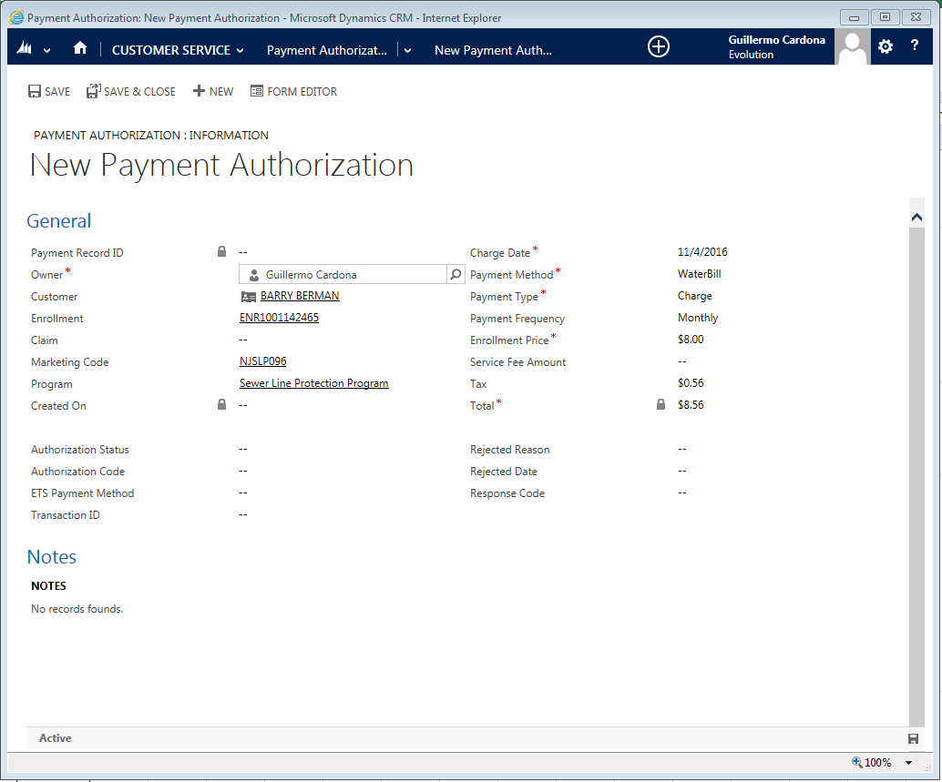

Figure : Payment Authorization Screen

The following fields are pre-populated:

* Customer
* Enrollment
* Marketing code
* Program
* Enrollment Price
* Payment frequency- one time, monthly, bi-monthly, quarterly, annually.
  + For payment other than one time, the reoccurring payments are scheduled in ETS on save by a plugin.
* Payment Method- Water Bill, Check, ACH, Credit Card, eCheck.
* Next charge Date
* Total
* Payment Type- Charge, Refund
* Payment Record ID is auto populated after Save, Format- PMTxxxxxx

Once the record is saved, a button will show up called *Payment*. When the user clicks on it, another window shows up. This contains elements from the ETS interface. The data passed to ETS is done via JavaScript, and contains the following:

* First Name
* Last Name
* Customer Number
* Record ID (Enrollment ID)
* Next Bill Date
* Payment Amount
* Payment Frequency
* Number of Payments
* Payment Method

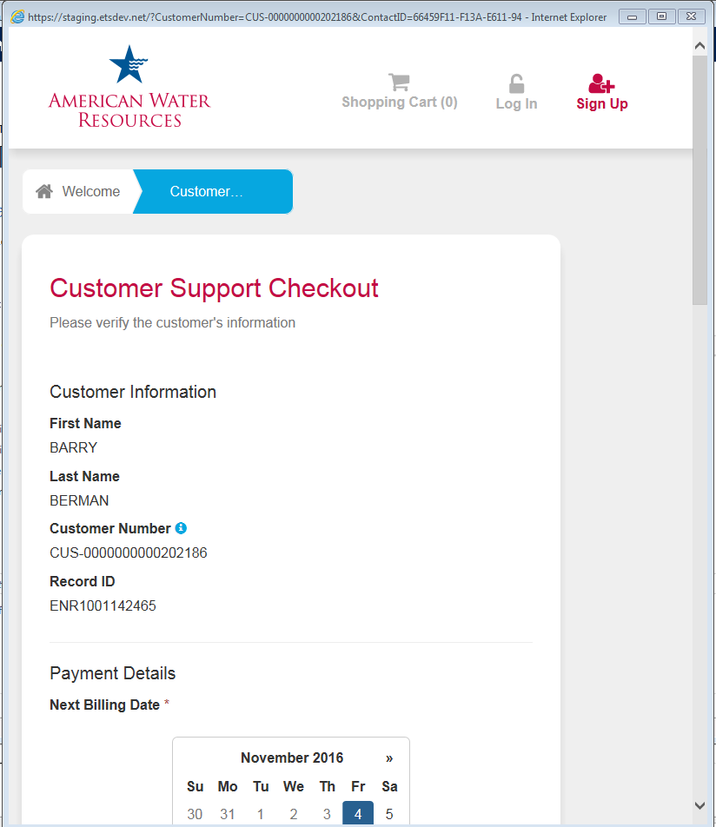

Figure : ETS Payment Screen

The user proceeds to verify the information and enters the Credit Card Information at the bottom of the page. If it is an ACH or eCheck transaction, the user enters the Bank account number and the Routing Number.

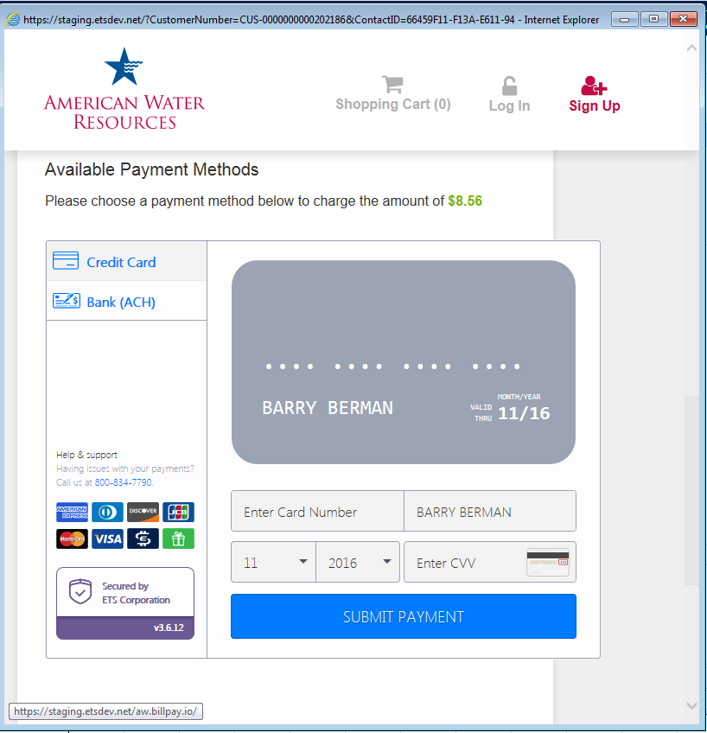

Figure : Credit Card information on ETS Payment Screen

Once the information is entered, the user clicks on Submit Payment. When this happens, the authorization gets processed, and the following information gets sent to CRM to the Payment Authorization record:

* Payment Authorization Status-
* Pending
* Authorized
* Cancelled
* Authorization code
* Response Date Response Code
* Transaction Id
* Plan Id
* Rejected Reason
* Payment method

##### Options available at Enrollment

**Auto Renew**

This gives the option to the customer to auto-renew, and if so, which payment method would be used for the new enrollments. Auto-enrollments are processed by Scribe on a daily basis.

**UPI and RPI Opt Out**

UPI (Universal Price Increase) and RPI (Renewal Price Increase) are functionalities that allow the AWE staff to increase the price of enrollments at a specific time (RPI is during renewal, UPI is at a specific date). The functionality if described in more detail in the ***Marketing Management*** section of this document.

At Enrollment, the user can set the field *RPI Opt Out* to Yes, taking the customer out of the RPI process. The same applies to the field *UPI Opt Out*.

##### Upselling to the customer

After the initial enrollment is saved, the user can offer additional enrollments to the customer while they are on the phone. If the customer agrees to enroll in additional programs, the user would just go back to the customer record, and using the business process flow form, clicks on the Enrollment stage and adds a new one.

Another way to upsell is to offer a combo program that contains multiple programs resulting in a higher revenue transaction. If this is the case, the user can then change the Marketing Code of the enrollment, before it is saved, to the appropriate marketing code that contains the combo program.

##### Mailroom Enrollment

This type of enrollment is done to process enrollment forms that a customer has sent via mail to AWE. Forms are received by the mailroom and delivered to the Customer Service team. These enrollments are done manually using the process described above after a customer search.

Most forms are a result of campaigns launched against customer records (Contacts) saved in the system. Therefore, in a typical situation, the user would search for the record using either Advanced Find or the Quick Search bar, find the customer, and create the enrollment. In the case that the customer is not found, it is created with the status equal to “Prospect”.

##### Lockbox Enrollments

Lockbox enrollments are those from customers that have sent the enrollment form with a check payment to an address belonging to the bank servicing AWE. The bank will process payments and capture all the enrollments in a CSV file. This file is sent to AWE for processing via an FTP site. Once at the FTP, Scribe will grab it and import the data into a staging database.

Additional checks are done to determine if the record in the file is for a new enrollment or if it is to renew an existing enrollment. If the process fails at any check, the system will create a Problem Enrollment, which is an enrollment record with the status of “Problem Enrollment” (Problem Enrollments are covered in the ***Problem Enrollments*** section). If there are no issues, either the existing enrollment will be renewed, or a new enrollment is created. If the payment type of the enrollment is ACH, a Payment Authorization record is also created. At this point, a plugin would contact the ETS web service and send the information for payment processing.

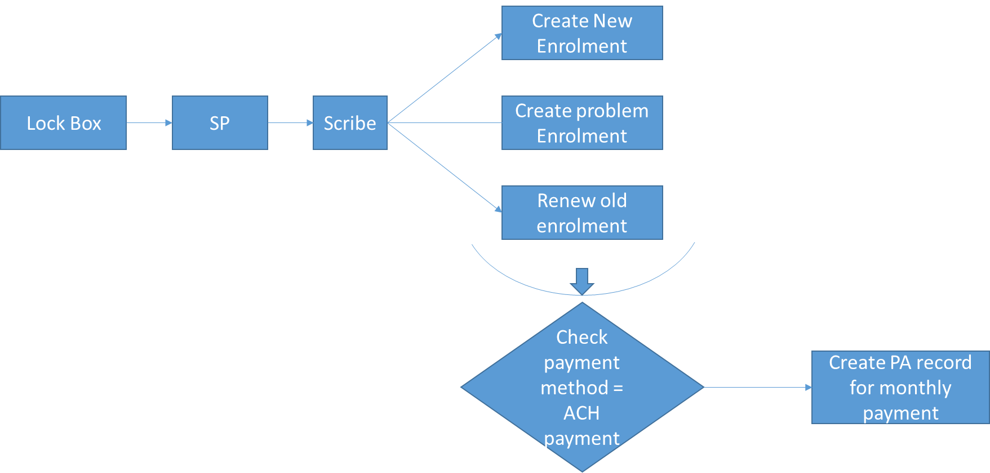

Figure : High Level Overview of the Lockbox process

The detailed process is described on the following PDF:



It is worth noting that this process is currently off as it is not working properly and creating duplicate records.

##### Online Enrollments

Customers have the ability to enroll online via either the AWE website if they are water bill customers, or via a separate website. For water bill customers, the customer would go to a page located on the AWE website. They fill out the information, and the website sends an email to a queue in CRM. Once received, a Customer Service agent processes the request.

For non-water bill customers, they are supposed to go to a portal that was built by their payment processing company ETS. However, this is not currently functioning.

#### Renewals

Enrollment renewals can happen automatically or can be done manually.

##### Automatic Renewals

Enrollments are set up for auto renewal unless the customer opts for non-renewal. The new enrollment will contain the same marketing code. If they are part of the RPI process, they will get the Replacement Marketing Code of the existing marketing code. RPI is discussed in more detail in the ***Marketing Management*** section of this document.

Enroll date will be parent end date+1 day, eligible date will be enroll date+1 day and end date will eligible date+ 1 year.

Automatic renewals are processed on a daily basis by a Scribe integration. Details about this integration will be covered in the ***Integration*** section of this document

##### Manual Renewals

A customer may decide to renew their enrollment manually either prior to cancellation or up to 30 days after cancellation. If this is the case, the user finds the enrollment that needs to be renewed, and clicks on the button “Renew” on the menu bar. This creates a new enrollment with the enrollment date set to the previous end date plus one, the effective date set to previous end date plus one, and the end date being a day prior to the enrollment date plus one year. The new enrollment is created as a child enrollment of the one being renewed.

The rest of the enrollment is processed as described before.

If the enrollment is expired, and 30 days or more have passed since expiration, the user would just create a new enrollment.

#### Cancellations

Cancellations happen either by request from a customer or as a result of a delinquency or shutoff. In this section, we will cover cancellations that are processed manually when the customer calls to cancel.

##### Saved Cancellations

If a customer would like to cancel, he or she can call the Customer Service desk and request the cancellation. The Customer Service agent tries to save the enrollment, as they are compensated when they do.

If there is no action needed to save the enrollment, and everything stays the same, the user changes the *Status Reason* field to “Saved”. The Save Data gets populated, and the field *Discount* is set to “No”.

If the user has to give a discount, he or she will then do the following:

* Set *Status* field to “Cancelled”
* Set the *Status Reason* field to “Saved”
* Enter details on the *Saved* section
* Enter a reason for the discount
* Set the *Cancellation Requested Date*
* Set the *Cancellation Reason*
* Enter any other details on the record
* Save the record

Once saved, the *Cancellation Date* field is set to one day prior to today’s date.

He user then proceeds to hit the *Calculate Refund* button on the toolbar.

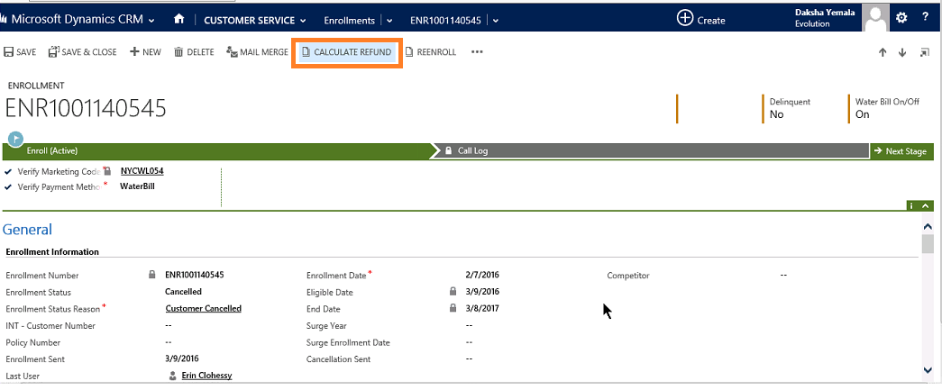

Figure : Calculate Refund Button

On Click of this custom ribbon button, JavaScript Action will trigger a request to the Dynamics AX system. Dynamics AX services give Refund Amount as output. Refund amount is updated in Enrollment.

Inputs:

* Enrollment number
* Location Code
* Cancellation date
* Cancellation reason

Outputs:

* Refund Amount when applicable
* Internal Billing Date
* Write off amount when applicable

An adjustment record will be created with the Refund amount and the custom ribbon button ‘Calculate Refund’ will be disabled.

Typically, for saved enrollments, the *Refund Type* field is set to “Credit”. This will then be rolled over to the new enrollment.

The next step is for the user to click on the *Request Refund* button, which sends all the information to AX and ETS if applicable. If there is a credit card refund to be processed, the system will create a new *Payment Authorization* record with the information, and send the data to ETS.

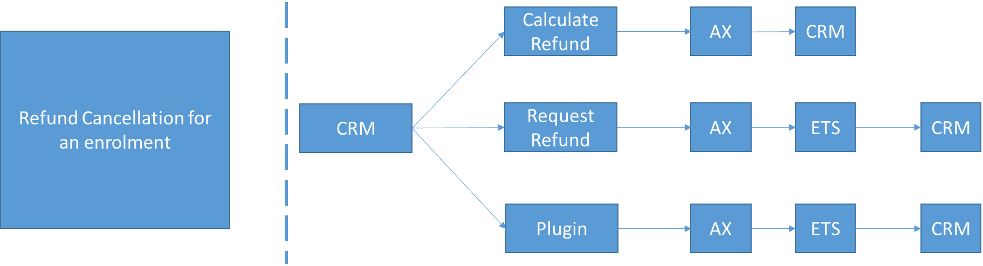

Figure : AX and ETS Integration for Refunds

As shown in diagram there are three ways where refund calculation gets triggered from CRM:

1. Click on Calculate Refund

When you click on this button present on enrollment record, a java script code is written that will get the refund amount from AX and update back in CRM

1. Click on Request Refund

When you click on this button present on enrollment record, a java script code invokes a custom action. A plugin which then subscribed on this action will be executed. This plugin will get the refund details from AX and also call ETS to process actual payment and come back in CRM to update payment related data along with creating Adjustment record.

1. Plugin written on cancel of enrollment

Enrollments get cancelled in bulk in process called shut off. After enrollment is cancelled a plugin is triggered that will go to AX fetching refund details and calling ETS web services for processing the refund and update back in CRM the payment details along with creating the Adjustment record.

The integration to ETS comes into picture only when *Refund Type* field is set to Credit Card. For the others, a manual process is followed.

At this point, the user then clicks on the *Re-enroll* button to create a new enrollment. The new enrollment is then created with the new marketing code that typically has a lower price. Payment frequency may change as well, although that is rare.

Once the new enrollment is created, Scribe sends it to Dynamics AX.

##### Non-saved cancellations

If a customer just wants to cancel, and the user can’t save the enrollment, the process is similar with the exception of:

* *Status Reason* is set to “Customer Cancelled”
* The *Enrollment Status* is tied to the *Customer Status Reason*
* After the refund is requested, the user clicks on the *Mail Merge* button on the toolbar. At this point, the user selects the letter that needs to be sent to the customer, which typically is “ALL – Cancellation Letter”.
* The user fills out the letter as the mail merge only brings in customer information (identified as a pain point).
* The letter is then saved as a PDF in SharePoint and emailed to the customer
  + In some cases, the letter is printed and mailed via regular mail.

#### Problem Enrollments

Problem enrollments are enrollments that are marked as having an issue from the Lockbox integration or an integration with entering enrollments as a result from mailers. Problem enrollments are assigned to the *Problem Enrollment* queue. Items assigned to that queue are managed by the Customer Service team. They would go to the queue, research the issue based on what shows in the *Enrollment Status Reason* field, and resolve it. Once resolved, the user goes to the *Queue Item Details* section, fills out the necessary fields, and changes the *Problem Status* field to “Closed”.

#### Technical Details

##### Plugins

|  |  |
| --- | --- |
| Plugin Name | Description |
| AutoNumber plugin solution  AutoNumberDefinition.cs  GenerateAutoNumber.cs | This plugin will generate auto number with the defined prefix and incremental number for a particular entity defined in the Auto Number Definition entity |
| ValidateCustomerAddress.cs | This plugin reads the USPS web service URL from evo_config.xml, sends the address details from customer form and gets the validated address response. |
| CalculateCCHAction.cs | This plugin reads the Input parameters from customer action such as location code, Program code, Payment method, Subtotal and passes the inputs to CCH_endpoint_address. The calculated tax amount is send back to custom action. |
| AXRequestRefund.cs | This plugin updates the AX with the details of cancelled enrolments and then gets the Adjustment data , calls the ETS web service and updates the payment authorization with Cancelled status and creates a payment authorization record with refund type, then creates the Adjustment record (on click of request refund , a custom action is called and the plugin is executed) |
| Enrolment.cs | This plugin handles the refund process for bulk cancellations of enrolments. if active enrollment already exists for same customer and product , then plugin restricts save of enrolment |
| LoadBillingAnd Payments.cs | This plugin gets billing and payment data from AX endpoint address and updates customer and enrolments. |
| AdjustmentRefund.cs | This plugin will update adjustment record with cch tax amount by calling to CalculateCCHAction.cs |
| PaymentAuthorization.cs | This plugin schedules recurring payments, updates enrollment status reason (HOS5 exception, saved, damaged payment). |
| Reoccuringpayments.cs | This plugin consumes ETS web methods like add ETS payment, Creates ETS customer id and planid. |
| ETSPaymentProcessor.cs | This plugin will create ETS payment and Update the Pyament Authorization Record with Transaction Id, Approval Code, ResponseCode and ResponseText. |

Figure : Plugins used by the Enrollment Management process

### Billing Management Process

The billing management team handles billing for customers, issues with billing, and invoice processing for contractors.

#### Shutoffs

Shutoffs come from Third Parties via integration. These are for customers that get billed on the Water bill by the third party. The third party sends a flat file that gets processed by Scribe. The enrollments in that file get the status changed to “Cancelled” with a *Status Reason* set to “AWR Cancelled”

The Billing team will then go to the enrollments and process them as a cancellation by doing a *Calculate Refund* and then a *Request for Refund*.

The *Water Bill* field set to off manually (supposed to be automatic). I the customer record, the field *Water Bill on/off* is set to “off”.

An activity is then created reminding the billing team to send a cancellation letter. This is done via the mail merge functionality.

Once the shutoff is processed, the billing team clicks on the *Queue Item Detail* button, which will then bring the Queue Activity record, and they will set the *Problem Field* to “Closed”

#### Problem Payments

Problem payments are records created when ETS cannot process a payment as part of an automatic payment plan. These payments are assigned to a Queue.

Enrollments that are assigned to the Problem Payment queue get the *Status* field set to “Suspended” and the *Status Reason* field set to “Failed credit card/ACH Payment”. Additionally, a letter activity gets created.

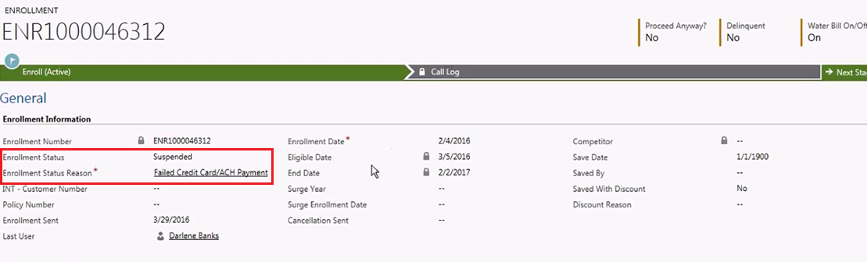

Figure : Enrollment with a Problem Payment

The Billing team goes to the queue, opens the enrollment record, and using the Mail Merge feature, they send a letter to the customer. This process is manual at the moment since the Mail Merge feature is not working 100%. The letter is stored in the Documents folder of the enrollment record, printed, and send via mail. Once this is done, the letter activity is completed.

If a customer calls back to address the issue, the user finds the enrollment, opens the payment authorization record that has the declined status, clicks on *Payment*, and process the payment again. Once approved, the user goes back to the enrollment, clicks on *Queue Item Detail*, and changes the *Problem Field* to “Closed” so that it doesn’t show up on the queue.

If the problem payment is not resolved after 30 days (40 days in California), the status of the Enrollment is changed to “Cancelled”. At this point, the cancellation process mentioned earlier would be followed.

#### Delinquencies

Delinquencies come from Dynamics AX on a daily basis by a combination of Scribe and Stored Procedures. The process of managing the delinquencies is divided into Daily Delinquencies and Monthly Delinquencies. The technical details of the integrations are discussed on the ***Delinquency Integration Process*** section of this document.

##### Daily Delinquencies

Once a daily delinquency record comes in, the enrollment and the customer record are both marked as “Delinquent” in the *Status* field. The integration also populates the delinquency amount, type, and aging.

After a certain number of days, depending on the state, a pre-cancellation letter or email will be sent. The rules are as follows:

* VA: 45 days after being delinquent
  + These get cancelled at 75 days after
* NM: 60 days after being delinquent
  + These get cancelled at 90 days after
* Rest of the US: 180 days after being delinquent

##### Monthly Delinquencies

This process takes the enrollments that are over 180 days delinquent and moves them to the “Cancellation Documentation” queue. The status is then changed to “AWR Cancelled” and the cancellation process is followed.

#### HOS5 Exceptions

HOS5 Exceptions are records that come from failures from the integrations that send enrollments, adjustments, and cancellations to the third parties.

The billing team reviews the items on the queue (they have different views depending on the third party), research the issue, and try to resolve it.

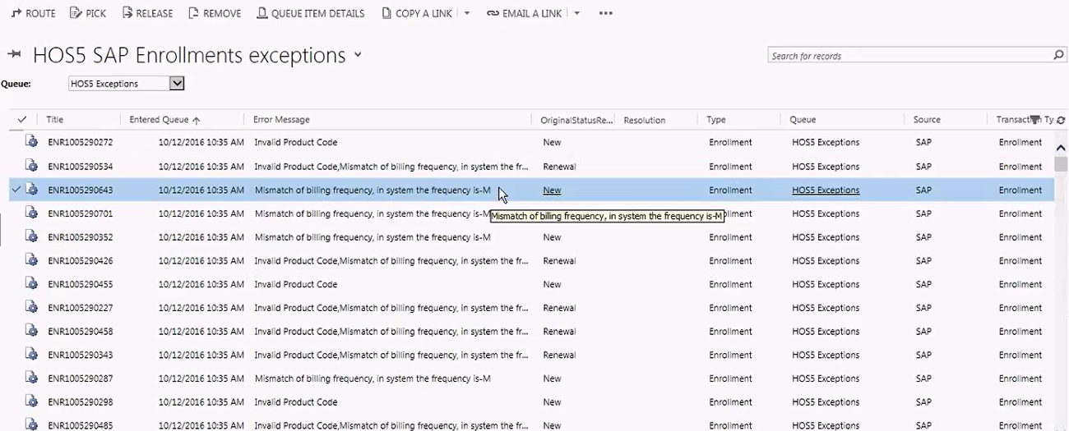

Figure : HOS5 Exceptions Queue View

Once resolved, they click on *Queue Item Details*, change the form to “HOS5”, record what was done, and if needed, check the box *Re-send* to “Yes” so that the enrollment gets sent to the third party again. Once that is done, the *Problem field* is set to “Closed” so that the enrollment doesn’t show up in the queue anymore.

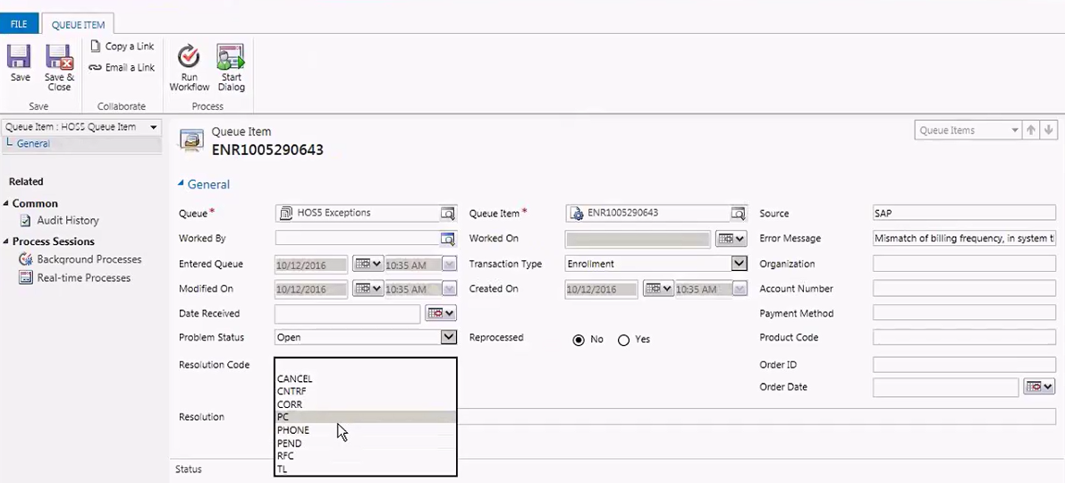

Figure : Queue Item Detail for HOS5 Exception record

#### Adjustments

Adjustments are records created for cancellations and refunds automatically.

There may be cases when a customer may request an adjustment due to an issue on the water bill, or due to customer service. If this is the case, the enrollment gets escalated. The Escalation them would then create a manual adjustment that gets sent to the third parties.

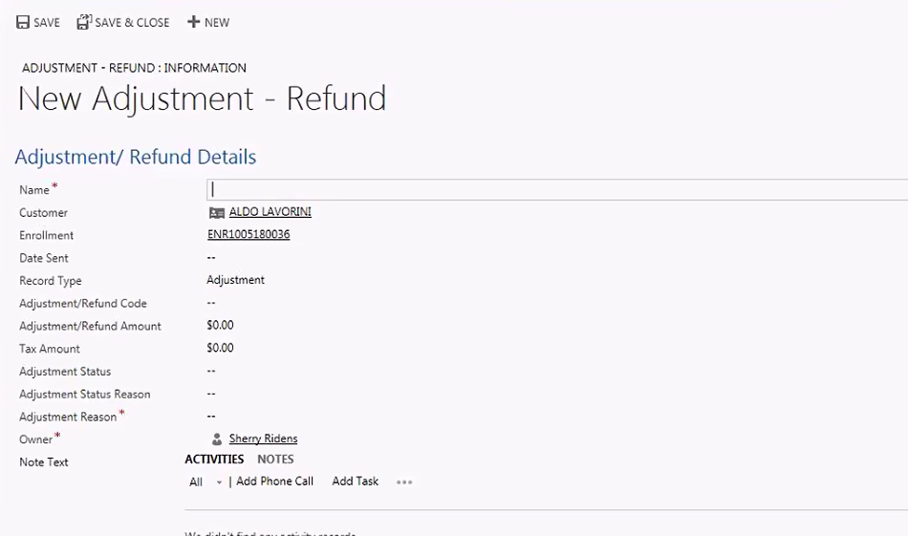

Figure : Adjustment Creation Form

#### Contractor Invoice Management

Contractors send invoices to AWE once the claims are completed via email. These are sent to a specific email address that is assigned to a queue in CRM (Invoice Inquiries queue). The user will open the email containing the invoice and open the attachment. If the contractor had a proposal done for the claim, the user would then open the proposal from the enrollment record, and click on *Copy to Invoice*. This would create an invoice record. If there is no proposal done, the user would create an Invoice record from scratch.

Once the record is created, the data is populated, and the original PDF is stored in SharePoint. The status of the enrollment changes, which triggers the integration to AX to update the PO with the current invoice amount.

On a daily basis, a user from Billing would open SharePoint manually (not through CRM), and browse to the folder that has all the invoices. While in SharePoint, they browse to the folder that has all the invoices. They would be grouped by dates. They then select to open the folder using File Explorer. From there, they would manually select the invoices that need to be processed, and they manually email them to an address owned by AP team.

Once the AP team receive the invoices, they scan them using ImageNow, and then reconcile against the existing POs manually.

### Contractor Management

Contractors are the companies that will service the claims raised by AWE’s clients. Contractors cover all of the United States, and are associated to different territories.

Contractors can service one or multiple territories. They can also sign up for servicing one or multiple programs.

Contractors are stored in the Account Entity.

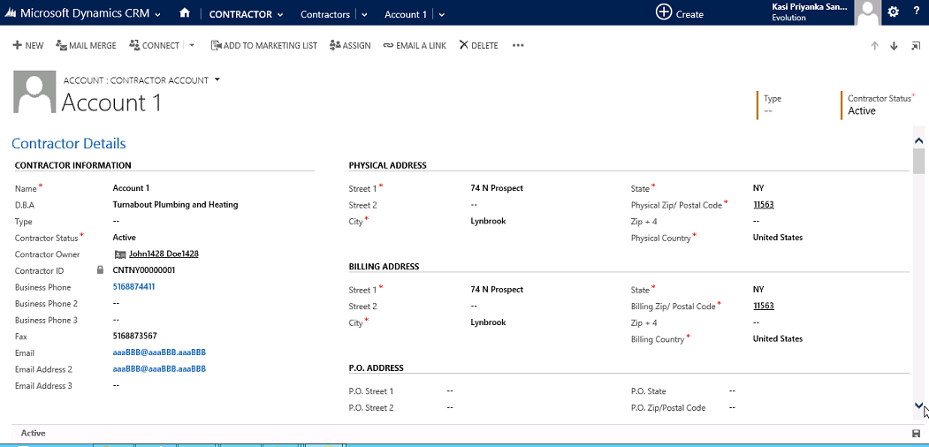

Figure : Contractor Form

#### Obtaining new contractors

There may be times when new contractors would be added to the list of contractors that AWE works with. This could be due to expanding on a new area or the offering of a new program. When this is done, the Marketing team conducts a marketing campaign targeting prospective contractors. The contractors are obtained from RRD (R Donnelly). Using Scribe, the data is imported into CRM and the campaign is created with the corresponding marketing list.

These campaigns are typically done via email or postcards. Interested contractors will respond via email or phone call. They can also go to a website that has a form that when filled out, it sends an email back to CRM.

The Contractor Management team handles the process of accepting a contractor as an active contractor. If the contractor is interested in performing the services for AWE, the Contractor Management team would send them a Vendor Procurement packet. They request the following:

* Certificate of Insurance
  + 4 possible types:
    - Workers Comp (must have)
    - General (must have)
    - Auto (must have)
    - Excess (not required)
* License on the product they are going to service
  + They need one license for each product
* W-9

The documents are received by the Finance team. When received, they will note that in the Finance section of CRM, which then flows to AX during integration.

Once the data is received and approved by Finance, the user goes to CRM and changes the fields *Create in AX* to “Yes”. This will create the record in AX as a Vendor. If Finance agrees with everything, they mark the record in AX as approved, which will then flow to CRM.

Figure : Contractor Creation process in AX

At this point, the contractor is set up as an out-of-network contractor, which means that no contract has been signed. These contractors can do business with AWE, but will not come up first in the contractor ranking tool. Once the contract gets signed, they then become in-network contractors, which come up first in the contractor ranking tool.

If the Finance team needs the Contractor Management team to review the record or provide more information, they will mark the record as such in AX and put the record in “Hold”. Scribe updates the record in CRM. Once the Contractor Team updates the information, the field called *Update in AX* is set to “Yes” automatically, alerting Scribe to send the record back to AX.

There may also be instances when the Finance team rejects the contractor. If this is the case, the integration from AX to CRM will update the status of the record with a status of “Rejected”.

Figure : Contractor Update process in AX

Contractors also have to be approved by the legal team. This may take some time. The process will create tasks for the legal team to review the information and approve them. Once approve, they change the *Legal Approval* field to “Yes”.

All contractors can service any type of claim for the program that they have signed up for, and if they are active or not.

Figure : Contractor Management Process

#### Territories and Zip Codes

Contractors are set up for one or multiple zip codes. The system contains all the zip codes from the USPS in an entity called Zip Codes. Contractors are then linked to the corresponding zip using a Many-to-Many relationship. This process is completely manual at this time.

Once the zip codes are entered, the territories to that corresponding zip code is assigned to the contractor. This is done via a plugin.

#### Job Types

The Job Types entity contains the different types of job s that a contractor can do for each program that they service. This is important for the Ranking Tool and Contractor selection process when a claim is processed.

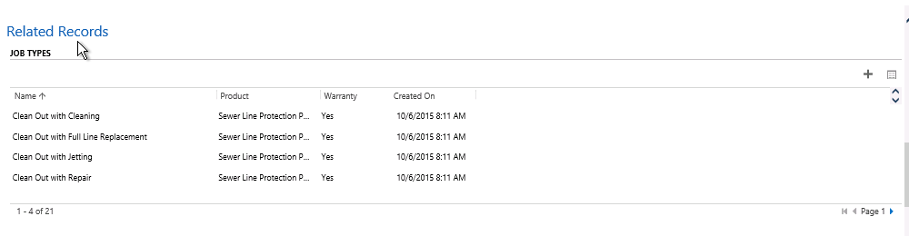

#### License/Insurance

The License/Insurance entity contains all the licensing and insurance records for the contractor. Every night, there is a Scribe job that checks this entity to see if the license or the insurance has expired. License expiration affects the ability of that contractor to do a service for a particular program. The Insurance expiration will affect the ability to do any service at all. There are more details on how the contractor is ranked and matched against claims in the ***Contractor Ranking Tool***section of this document.

#### Agreements

The Agreements entity contains the agreements signed by the contractors with AWE. Each agreement contains the list of programs that the contractor has agreed to service. There is no expiration, and they are good for the life of the relationship. Each time a new agreement gets signed, a new record gets created.

Currently, this is not being used in the ranking process.

#### Employees

Contractor employees are entered into the Contact Entity in CRM. The owner’s information needs to be entered with more detail. Employee information is optional, and does not require as much detail.

#### Contractor De-authorization

In some cases, the contractor may be de-authorized to do business with AWE. In most cases, it is due to either a license expiring, or the insurance expiring. Scribe will run a process nightly and check for expirations. If the license expires, the status is set to “De-authorized” for that license or program. If the insurance is found to be expired, the overall status of the contractor is set to “De-authorized”.

The contractor will get an email 30 days prior to the license getting expired. The day of expiration, they also get another email. In some cases, if the contractor does a lot of business with AWE, the Contractor Management team will call to follow up. When the license is renewed, they do so manually in CRM by creating another license record.

#### Contractor Ranking Tool

Contractors are chosen for a claim based on a set of criteria. The first is based on the zip code of the claim, which will determine the territory being serviced by the contractor. Once that is established, the system verifies the following:

* That the contractor is active and not de-authorized due to insurance issues
* That the program can be serviced by the contractor
  + They must have a valid license to service the program
* That the contractor can service the type of customer (Residential vs. Commercial)
  + Contractors can be set up to service one or both types
* Verify that the contractor can perform the job type specified on the claim

If the contractor meets that criteria, they will show up on the *Contractor Ranking Tool* area when the user clicks on the ***Search Contractor*** button on the claim record.

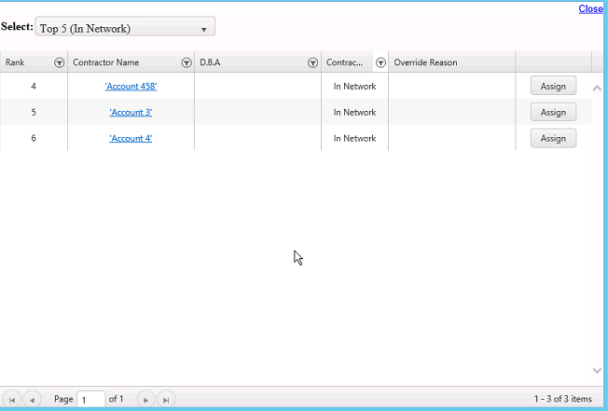

Search Contractor Window

The order, or ranking, is based on the following:

* In-network contractors show up first
* Ranking is then done by territory based on survey questions for customer satisfaction
  + These surveys are conducted on a quarterly basis
  + An admin can manually override the ranking of a contractor for each territory for each program they service. This is supposed to be taken into account when the contractors are ranked.

##### Survey

* Each Survey is categorized based on the “Survey Type” option set with the below options
  + Claim
  + Enrollment
  + Renewal
  + BI
  + Ad-Hoc

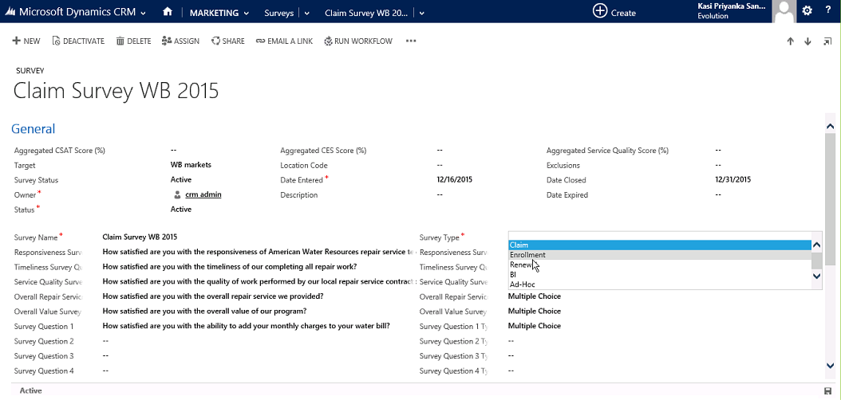

Figure : Survey Form

##### Survey Feedback

* These responses from the customer for the survey questions are stored in the entity called “Survey Feedback”
* Responses are captured on scale of 1-5
* These responses are created either manually or through a file import

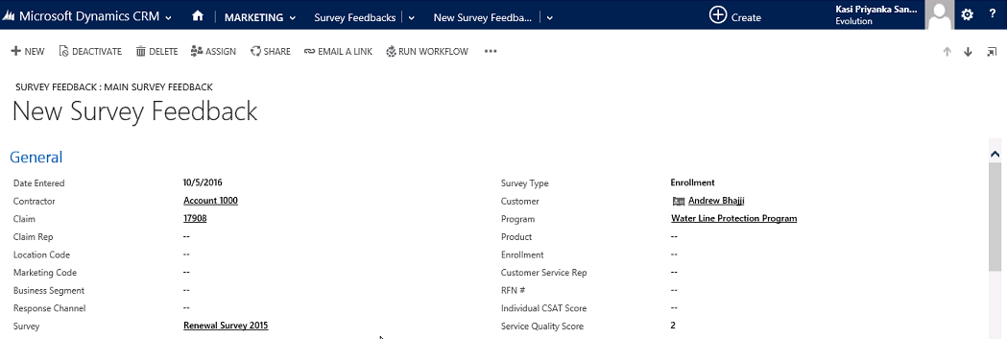

Figure : Survey Feedback Form

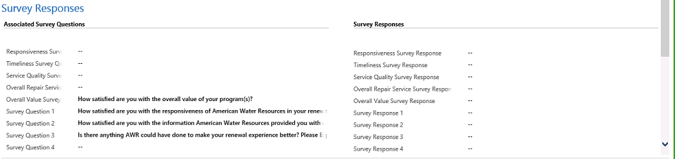

Figure : Survey Response Form

* Rankings are stored in the Ranking entity.

Below are the steps for how the tool is supposed to work, per the Technical Design Document:

* This will be a two part solution where in the ranks will be calculated in a stored procedure that will store the calculated data in staging table. The staging table will act as a source to the DTS.
* The DTS which is scheduled to run at a particular date will update the rank records in CRM. The record will be identified using the unique combination of Contractorid Job Types/Product, and Territory.

Stored Procedure - **StagingCRM.sp_awePopulateContractorRanking**

##### Stored Procedure logic

* Quarter dates: Quarter dates are predefined in a temp table and will be as below. A table to store the quarter values is needed as they don’t match the general SQL date functionality.
  + Q1 – 12/01 to 02/28 or 02/29 depending on leap year
  + Q2 – 03/01 to 05/31
  + Q3 – 06/01 to 08/31
  + Q4 – 09/01 to 11/30
* The year calculation will be done at runtime and also the check for leap year for Q1.
* Leap year: In case of the calculation of Q1, the current year plus one will be assumed and the end date would be of the new calculated year (leap year calculation will also be on the same calculated year)

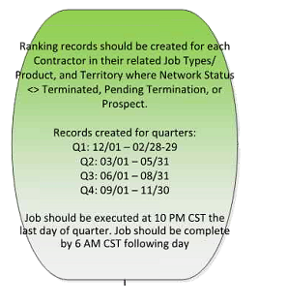

* Terminated contractors and contractors Pending Termination are excluded from ranking. De-authorized contractors are still processed for ranking.
* Contractors will have multiple ranking records.
  + For example:
  + Q1: Work done in 2 territories, for four Job Types = 8 Rankings
* Scheduling handling logic :A if-else statement will be implemented that will initially check if the current date is the defined quarter end date, if it does not satisfy the criteria the SP will not be executed. This will create zero records and hence no records will be updated/created in CRM.
* CSAT (Customer Satisfaction) – Is calculated using all survey feedback records created in the previous quarter and linked to that contractor. The score is calculated using question 2 from CSAT survey feedback weighted 75%. And using question 3 from CSAT survey feedback weighted 25%.
* In case the contractor has no Survey Feedback records for the previous quarter, then the score is calculated using .8 as the average for questions 2 and 3 in the CSAT calculation.

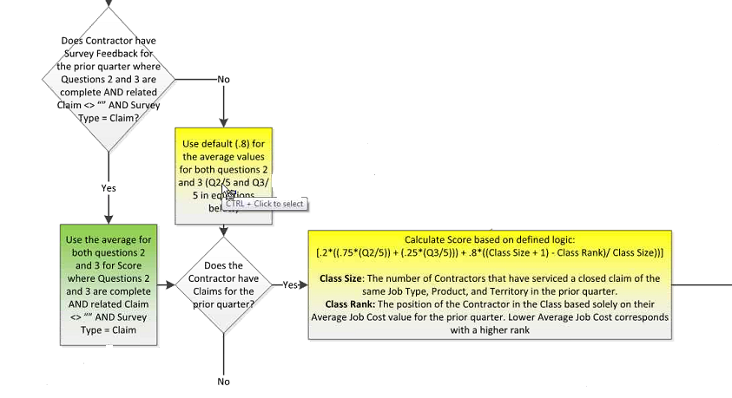

* In case the contractor has no Claim records for the previous quarter, then the CSAT is calculated only based on Surveys.
* The stored procedure will be using the below pre-defined/calculated data.
* Class Size: The number of Contractors that have serviced a closed claim of the same Job Type, Product, and Territory in the prior quarter
* Class Rank: The position of the Contractor in the Class is based solely on their Average Job Cost value. Lower Average Job Cost corresponds to a higher rank

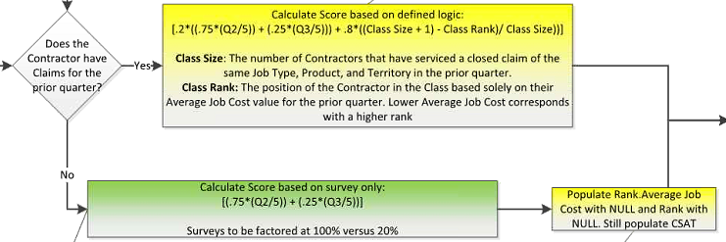

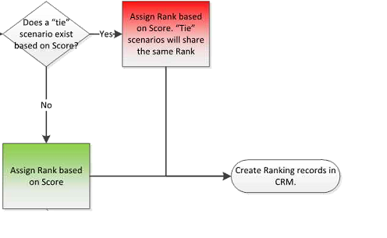

* Check for tie scenario based on Scores calculated for Contractors
* Contractors with same score will share the same rank

##### Scribe job – EXT012 – Contractor Ranking

* A scribe dts job is created to execute the stored procedure and create the ranking record with the calculated Score and Rank values for the services provided by contractors
* Scribe job is scheduled daily to check if today’s date is the end date of a particular quarter
* Scribe job updates its Execution date and time in the Environment Configuration entity for the Contractor Rank date Time record

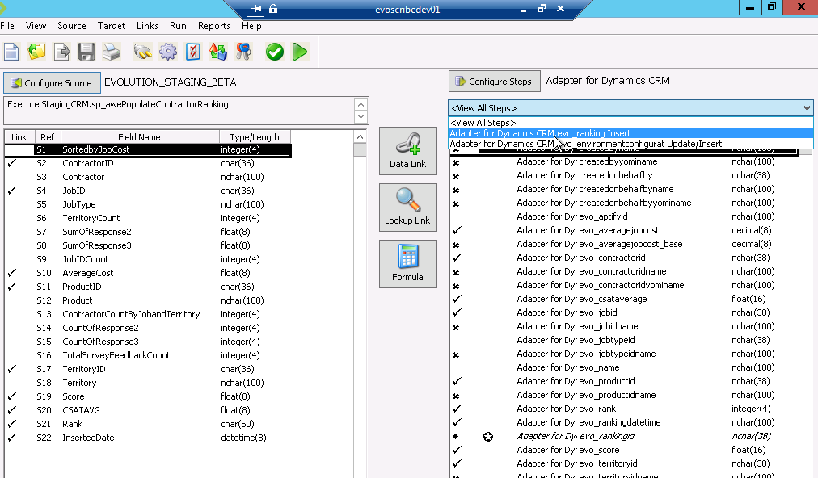

##### Deactivate Ranking records

* After 180 days the Ranking record will be expired. A Scribe DTS package (**EXT012 – ContractorRanking_SetRankingRecordsInactive**) will deactivate the ranking records that are180 days older
  + Runs every month, gets the Ranking records that are 180 days older in CRM system and updates the Status of the Ranking records to ‘Inactive’

** It was mentioned that this process currently is off due to defects **

##### Rank Override

Rank override is manual operation used to increase or decrease rank. Contractor listing in Claim is dependent on the Rank & Rank override. Every Rank override has an expiry rate beyond which it will not be considered for the Ranking.

Rank override can be created for ‘Raise Rank’, ‘Lower Rank’, ‘Priority 1 Rank’, ‘Priority 3 Rank’ and ‘unavailable’

* Priority 1 & 3 – makes the Rank as 1 & 3 respectively
* Raise Rank – Increases the score by 25%
* Lower Rank – decreases the score by 25%
* Unavailable – avoid the contractor from listing

#### Technical Details

##### Plugins

|  |  |
| --- | --- |
| Plugin Name | Description |
| AutoNumber plugin solution  AutoNumberDefinition.cs  GenerateAutoNumber.cs | This plugin will generate auto number with the defined prefix and incremental number for a particular entity defined in the Auto Number Definition entity |
| Contractor.cs | This plugin gets the open claims for the Contractor whose status is terminated and assigns the open claims to need contractor queue.  And also does the Association/dissociation of territories. |

Table : Plugins used by the Contractor Management Process

##### Business Rules

* Terminated Contractor Business Rule
  + When the Contractor status is Terminated, the Termination Reason and Termination Note are required
* AX Create/Update Business Rule
  + To prevent Users from selecting Create and Update AX at the same time
  + If AX status contains data, show Update AX and hide Create AX fields
  + If AX status does not contain data, hide Update AX and show Create AX fields

##### Workflows

|  |  |
| --- | --- |
| Workflow | Description |
| Contractor Finance update alert Workflow | Triggered when the AX Status field is changed  Creates Task owned by Contractor team  Creates Queue item , Queue – Procurement |
| Contractor Legal approval alert Workflow | Triggered when Legal Approval field changes to Approved  Sends email to Contractor team distribution list |
| Need Contractor Workflow | Triggered when Claim status changes to Need to Contractor  Creates queue item, Queue – Need Contractor |
| AX Need Information alert Workflow | Triggered when AX Notes is Need more information  Creates Task, Owner – Contractor Team, Due Date – Process Execution Time + 3 Days  Creates Queue, Queue – Contractor Procurement |
| Terminate Contractor Workflow | Triggered when Contractor Status changes to Terminated  Updates AX to Yes |
| Contractor Termination letter Workflow | Triggered when Contractor Status changes to Pending Termination  Creates Task , Owner – Legal Team, Due Date – Process Execution Time + 3 Days  Creates Queue , Queue – Legal Approval |

Table : Workflows used for Contractor Management

### Claims Management

When a customer from AWE needs service covered by one of their programs, they contact AWE and raise a claim. Claims are handled by the customer service team in most cases. AWE does use a third party, but they don’t have access to CRM.

Claims can be one of these types:

* Regular claim
* Settlement
* Warranty Claim
* Denied Claim

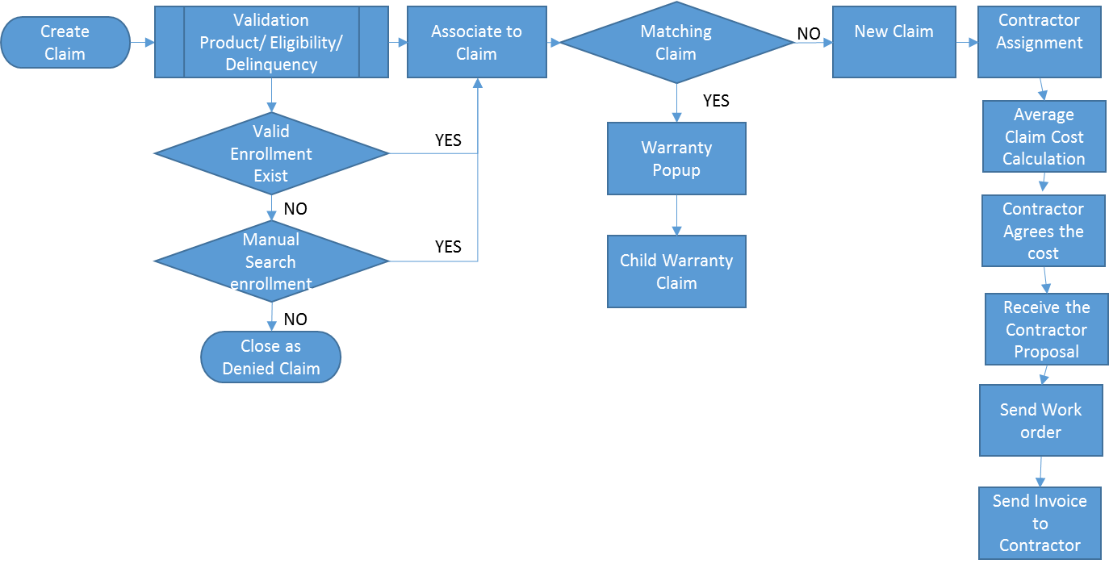

Figure : Claim process

#### Claim creation

When a customer calls AWE for a claim, a Computer Telephony Integration (CTI) to bring up the customer record from CRM. The CTI uses the customer’s phone number. If the phone number is not found, the CTI brings a search screen so that the user can search for the record using different criteria (see Figure 5 on the ***Enrollment Creation*** section of this document). In some other cases, the user may use Advanced Find to find the record and the applicable service address.

Once the customer record is found, the user validates the customer’s contact information. The claim is then created against the customer’s record going to the Claims Entity (clicking the drop down arrow next to the Customer’s name on the top blue bar, and selecting Claims), and clicking on Add New Claim.

When created, a JavaScript function validates the enrollment in the following manner:

* Product of the claim is the product associated with the enrollment
* The claim date is within the *Enrollment Eligible Date* and the *Enrollment End Date* fields.
* Customer is not delinquent

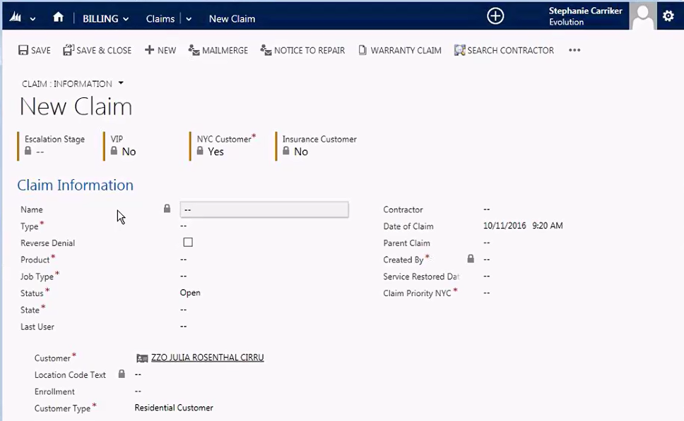

Figure : Claim creation form

If the criteria above are not met, the claim is saved with a “Denied Claim” status.

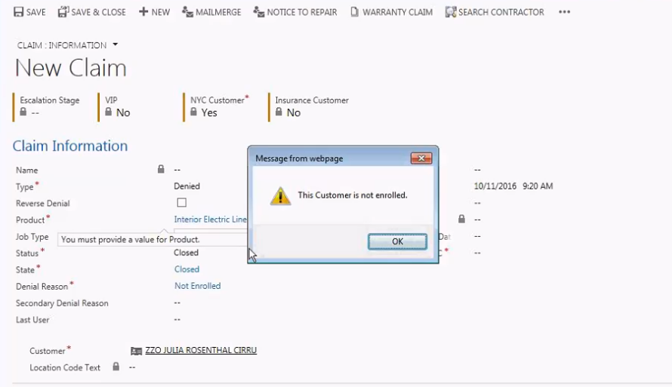

Figure : Claim creation -Denial

The user finishes entering more details for the claim, and saves the record. Once saved, the territory auto populates based on the zip code of the servicing address as well as the location code. In addition, any fees associated with the claim will auto-populate based on the marketing code of the enrollment. Service fees can be paid in advanced by creating a payment authorization record and then going to ETS to collect the payment. They can also pay the contractor when the claim is serviced.

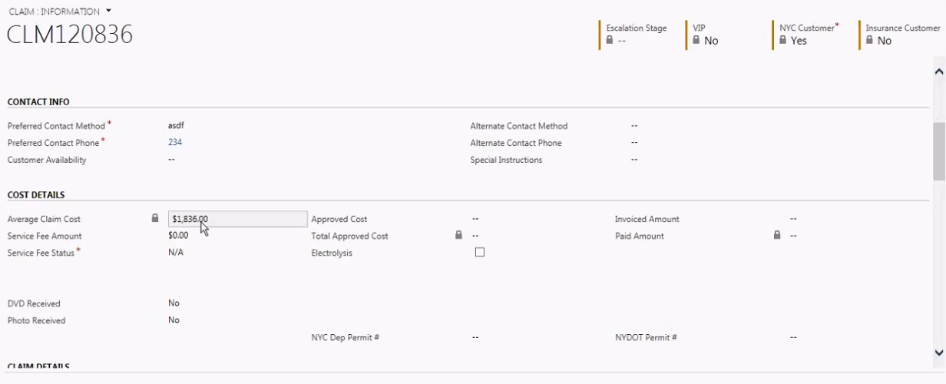

Figure : Claim Cost details

Claim history is captured in the grid which records any change in status, state or product along with the event date & time.

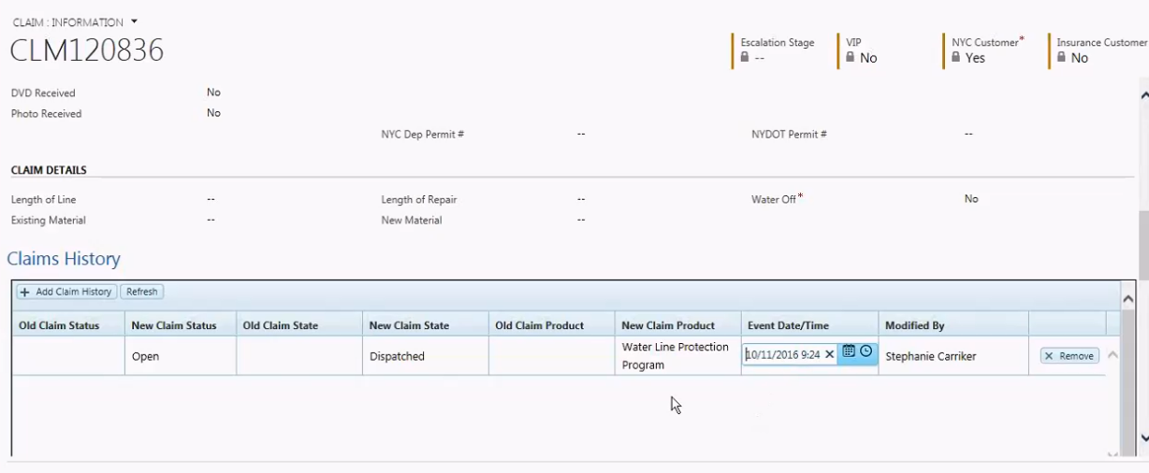

Figure : Claim Cost details

#### Contractor Assignment

To assign a contractor, the user clicks on the “More Buttons” or “Ellipsis” button, and click on *Search Contractor*. At this point, the Contractor Search screen shows up, with the ranking determined by the Contractor Ranking Tool as described in the ***Contractor Ranking Tool*** section. Once a user finds a suitable contractor, he or she contacts the contractor by phone while the customer waits on hold. If the contractor agrees to service the claim, the user clicks on the *Assign* button on the form.

When this happens, code behind the scenes will populate the average claim cost based on the location code and the job type for that claim. In addition, an email is sent to the customer with the details of the claim (plain text). In addition, there is an integration that sends to AX the cost details along any service fees and creates a PO for the contractor’s Vendor record.

After this, the user clicks on the *Notice to Repair* button. This opens a mail merge document that is supposed to populate the details of the claim and the customer and saves it in SharePoint. Once completed, the manually send it via email to the contractor or fax it, depending on the contractor.

In case if there is no contractor matching the Product, job type and territory of the claim, the claim is assigned to *Need contractor Queue.*

#### Proposals

In most cases, the contractor will agree to the claim based on the average claim cost. However, they may find once they visit the client, that the claim cost is going to be higher. If this is the case, the contractor will send an email to AWE with the details of a proposal with cost information. This proposal is created in CRM by the Customer Service team on the Proposal/Invoice entity. The proposal goes through an approval process, and if approved, the status is changed to “Approved” and the amount of the proposal is entered in the claim record manually.

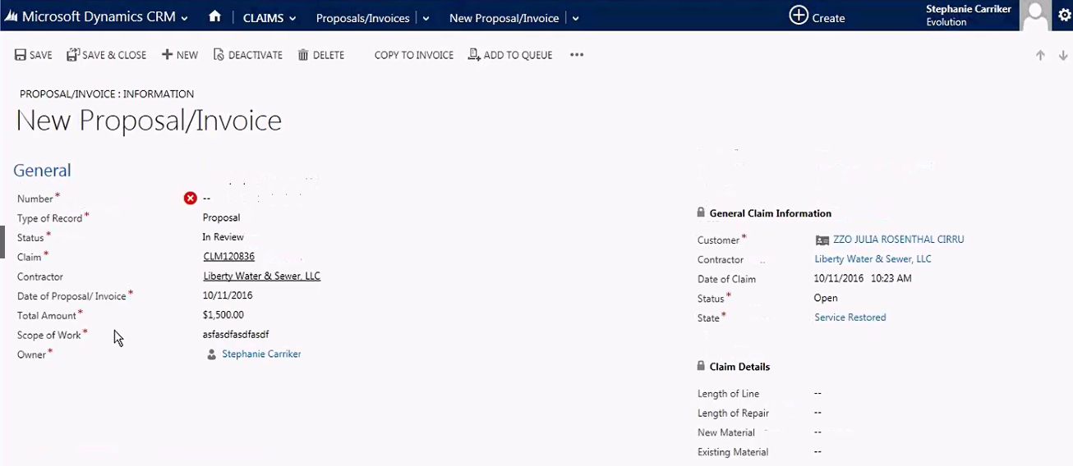

Figure : New Proposal/Invoice form

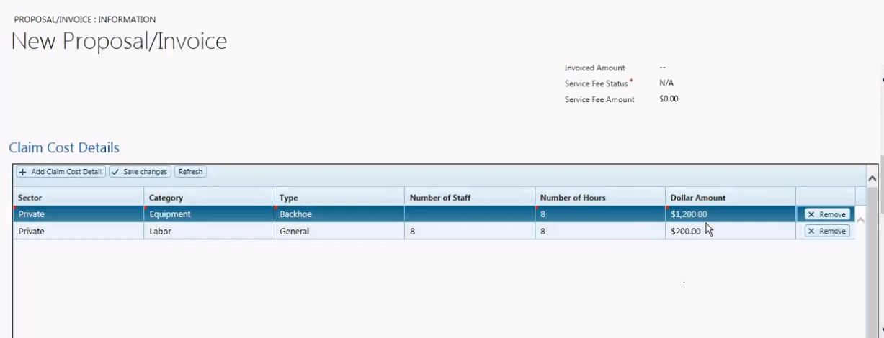

Figure : New Proposal Creation form

Proposals can be converted to invoices once the claim is completed, as described in the ***Contractor Invoice Management***section.

#### Warranty Claims

Claims completed for customers have a warranty of 60 days, regardless of the customer’s status. There are some claims that have a warranty of 12 months.

To create a warranty claim, the user finds the previous claim, and clicks on the *Warranty Claim* button. This creates a child claim with details from the original claim. The new claim may have some cost, and are processed as regular claims. The cost of the warranty claim will update the overall cost of the parent claim. A separate PO gets created in AX for payment processing.

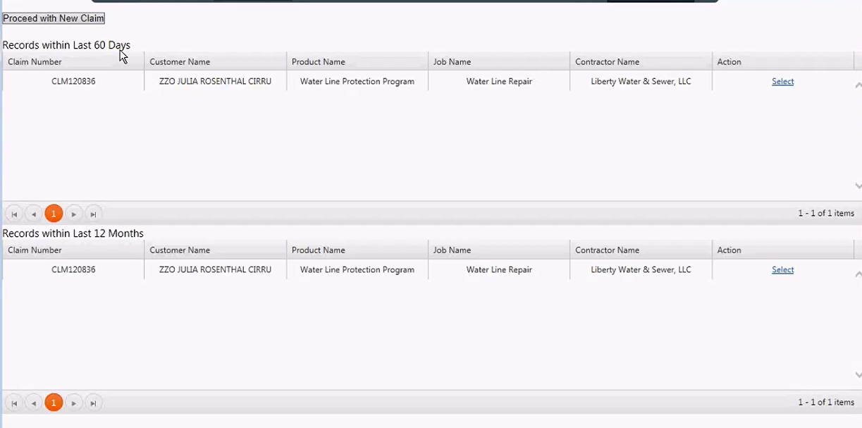

Figure : Warranty Pop Up

#### Settlements

Settlements are used when AWE has to settle with a client on the cost of a claim. A typical situation is when a client pays for a contractor themselves out of their own pocket. Other cases could be when the claim goes over the limit for a particular type of claim. AWE may agree to pay over that limit.

There are a lot of approvals for this type of claim.

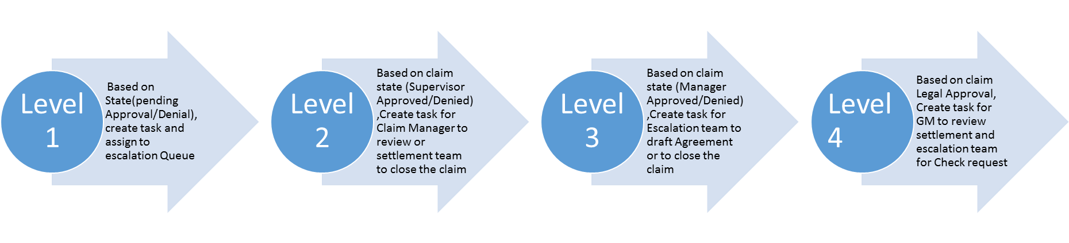

** The details on this will be provided after secondary support **

Once the claim is approved, a mail merge is created manually. Additionally, the data flows to AX as a Sales Order with the customer being a one-time customer.

#### Technical Details

##### Workflows

|  |  |  |
| --- | --- | --- |
| Workflow | Trigger | Action |
| Default Claim Status | On Claim Creation | Update Field Value  Claim Status = Open  Claim State = Dispatched |
| Clear Job Type | On Status Update | Clear field value  Clear the Job Type field  AND Job Type = Business Required |
| Default Credit Card Paid to Child Reassigned Claim | On change of FEE status Field | Default field value  On creation of Child Claim:  IF Service Fee Status = CC Paid  THEN on New Child Claim  Service Fee Status = Business Required |
| Show Water On Field | If Product selected is ‘Water Line’ | Show ‘Water On’ Field and make it Business Required |
| Set Claim Status to Open |  | IF Claim Status = Open  THEN Claim State = Dispatched |

Table : Workflows used by the Claims Management Process

##### Business Rules

|  |  |  |
| --- | --- | --- |
| Business Rule Name | Condition | Action |
| Denied Claim Field Visibility | Claim type = Denied | Show Denial Reason & Secondary Denial Reason Fields |
| Deny Claim due to Delinquency | Delinquent= Yes | Set the Claim as denied and close the record |
| Denial Reason Business Required | Claim type = Denied | Denial Reason is Business Required |
| Drive Optional Fields off of Claim Type | Claim type = Denied | Change requirement type of Job Type and Contractor as Optional and Product as Required |
| DVD Received Visibility | DVD received = Yes | Set DVD received Date & DVD Received By field visible |
| Photo Received Visibility | Photo received = Yes | Set Photo received Date & Photo Received By field visible |
| Reassigned Reason Visibility | Claim State = Reassigned to New Claim | Set Reassigned Reason visible and Required |
| Total Approved Amount Visibility | Claim Parent ID doesn’t have any data | Set Total Approved amount Visible |
| Settlement Type Visibility | Claim type = Settlement | Set Settlement type visible |
| Claim Closed By Visibility | Claim Status = Closed | Set Claim Closed by visible |

Table : Business Rules used by the Claim Management Process

##### Custom Actions/Buttons

|  |  |
| --- | --- |
| Custom Button | Action |
| Search Contractor | A Html page opens with a Sub grid listing the Contractors matching the product, Job type & territory. The contractors are listed based on Ranking |
| Reassign Contractor | Opens a new claim form and parent claim is closed with status set to Reassigned to new claim |
| Partial Denial | Opens a new claim form with status set to denied and closed |
| Settlement Claim | Opens a new claim with type as Settlement and details from Parent claim |
| Run Average Cost | JavaScript passes the customer, Job type and product and fetches the Average cost |
| Warranty Claim | Opens a new claim with type as Warranty |
| Notice to Repair | A pop-up windows opens for the User to select the template for documentation. Information from claim loads to the document and its saved in SharePoint |

Table : Custom Buttons used by the Claims Management Process

##### Plugins

|  |  |
| --- | --- |
| Plugin Name | Description |
| AutoNumber plugin solution  AutoNumberDefinition.cs  GenerateAutoNumber.cs | This plugin will generate auto number with the defined prefix and incremental number for a particular entity defined in the Auto Number Definition entity |
| Claim.cs | This plugin does some of the functionalities like updating the total approved cost in parent claim , populates the territory based on the Customer zip code, |

Table : Plugins used by the Claims Management process

#### Escalations

Escalations are created when customer complaint about an issue with billing, a claim, customer service, etc. To track escalations, the customer service team users the Case entity.

To create an escalation, the user, while working on the phone call activity tracking the call, will set the *Escalation* field to “Yes”. When this is done, a workflow will create the appropriate tasks and the case for the escalation team to work on.

Currently, there is a defect where all users are seeing all the escalations when only certain users should see them.

### Marketing Management

The Marketing team handles are the marketing campaigns for AWE. In addition, they maintain all the marketing codes, any RPIs (Renewal Price Increase) or UPIs (Universal Price Increase), and location codes.

The team is divided into two groups:

* Retention group:
  + Focuses on existing customers
* Acquisition group:
  + Focuses on getting new customers

#### Prospects

Prospects are obtained from multiple sources and are all imported into CRM using different integrations.

##### RR Donnelly

RR Donnely (RRD) is the company that AWE works with for campaign launches, prospect analysis, and regression modelling. The provide prospects based on a number of variables.

One of things that helps in the analysis is the fact that RRD has data from AWE regarding their business. Every week, RRD receives the following:

* Transactions
  + These include Customer Enrollments, delinquencies, etc.
* Suppression
  + This is the file that includes people that have opted out any marketing communication
* Invalid Credit Card
  + This contains the enrollments with invalid credit card, and it is used to request a different payment method from the customers
* Claims
  + This is a Delta File of claims that could be considered closed. This is used to market to people close to customers that have had claims in the past.

When AWE is ready for a campaign, they work with RRD to get the list of prospects using all the information that they have as mentioned above. In addition, they have other variables that can be used (they start with 400 of them, and end up with 8-10). The final outcome is a list of prospects that gets sent to AWE via a flat file. The file contains the following:

* Prospect information
* Campaign information
* Marketing Code
* Product offered
* Variable information with an expiration date for each variable

The original intent was to get two separate files: one with campaign information and another with prospect information. Currently, they get one file with both.

This file is sent to an FTP site that Scribe monitors. When received, Scribe will put the data into a Staging database. After some processing, the data is sent to CRM. Details of this integration will be covered in the ***RRD Prospects into CRM*** section.

The data that they get from RRD can be owned or rented. If it is rented, they will get an expiration date for the prospect record. In some cases, the variable information will have expiration dates as well.

##### Third Parties

Prospects from Third Parties as well by letting AWE to obtain a list of their customers. The third parties that allow this are:

* All American Water clients (come from SAP)
* Orlando
* Nashville
* NYC

The customer list for these third parties are also flat files. The integration is covered under the ***Prospects from Third Parties*** section.

#### Campaigns

Campaigns are broken down to different markets:

* AW customers (based on name recognition)
* Non-water bill customers (where they may or may not get recognized)
* Partnerships with other companies
  + Some will provide a list as well as the ability to use their logo

Campaigns are typically started three months before the launch. The team will go through different iterations or matrices to determine which audience to market to.

There are several types of campaigns. Examples include:

* RPI
* UPI
* Maintenance
* Surveys
* Acquisition
* Retention
* New Product Launch

Campaigns are created manually in CRM by the Marketing Team. A parent campaign will be created for the overall marketing effort. Then, child campaigns are created for each segment. This is due to a specific need in reporting.

Once the campaigns are created, a Marketing List gets added to the campaign they are working currently. The List is then configured with the prospects that will receive the marketing material using the Advanced Find. Campaign activities are typically done by RR Donnelly (print) or by the AWE team on Marketo.

All campaigns are set up in advance. Prior to the year starting, the team already knows how many campaigns will be launched and how many people will be included in those campaigns. Even so, there may be fluctuations based on changes with partnerships.

#### Marketing Code

The marketing code is used to determine, among other things, the pricing used for the enrollment. Fees that should be billed are also included in the marketing code as well as coverage limits, disclaimers, and coverage types or programs.

All enrollments are assigned to a marketing code.

#### Location Code

Location codes help drive eligibility for product as well as price and payment method. There are 111 location codes. Each location code has multiple marketing codes associated with them.

Location codes are very important for AX as well as for budgetary reasons. It helps AWE differentiate among the different markets

In the location code, if the name contains:

* 100 -> It is for American Water customer
* 150 -> it is for out of footprint
* 200 -> is for partnerships

The NYC location is so big that is treated differently.

#### RPI

RPI stands for Renewal Price Increase. It is the practice of selecting a group of enrollment that would have a certain marketing code and process them so that by the time they renew, they get a new marketing code.

First, the team identifies which marketing codes would get a replacement marketing code at the time of renewal. They then manually change the codes that need to be changed. Then, a marketing list is created with an *RPI Code* associated with it.

The process continues with the identification of enrollments with the help of RRD. Once the enrollments are identified based on a list of conditions, RRD will compile the file and send a list of enrollments along with an *RPI Code* to AWE. The list of records gets imported via Scribe and associated to the marketing list with the same RPI Code. At that time, the integration is also supposed to bring in the customers associated with those enrollments and add them as members of the marketing list (this is not currently working).

That night, Scribe’s Enrollment Renewal job will run and create new enrollments for those enrollments that need to be renewed, where the customer has not opted out of the RPI (additional conditions are also met, documented on the RPI Functional Design Document), with the *Replacement Marketing Code* as the enrollment marketing code.

*** Currently, this functionality is not live and as of the date of this document, several defects were still active ***

#### UPI

UPI stands for Universal Price Increase. It is the practice of selecting a group of enrollments that would have a certain marketing code and process them so that they get an increase on a specific date, regardless of their renew status. Unlike RPI’s, which take effect at the renew time, UPIs take effect immediately on the UPI Date.

Customers can also opt out of UPIs.

** This process is being built **

#### Ordinances

The Ordinances entity is used to track city, county, or state ordinances. The data is used in acquisition campaigns. Ordinances are supposed to be tied to zip codes, but it is not yet.

#### Marketing Plans

Marketing Plans are used for budgeting for campaigns and for analytics. This is a functionality that is not currently in use, but will start getting used in 2017.

### Quality Audit

Quality audits are done to ensure that certain records and operations are done properly. Auditing is done for:

* Enrollments
* Claims
* Proposals
* Queues

#### Audit Process

The Audit team looks for records using the Advanced Find tool. They then select on any record and click on the Workflow button to launch the On-demand Workflow assignment tool. From there, they select the corresponding workflow, depending on the type of audit that they want to perform. The workflow creates a record in the Audit entity.

To perform the audit, the team goes to the QA & Training module, and from there, they select the Audit Entity. The Audit team works on the audit record, check the validation at each business process stage and updates the status as ‘Pass’ or ‘Fail’.

If the Status = ‘Fail’, a Corrective Action record is created and assigned to the owner of the record. The owner can either Appeal or Complete on the Corrective Action record.

On Appeal, the audit team will cross check the parent Audit record and update status accordingly

On Complete, a new audit record is created with the original Audit record as parent.

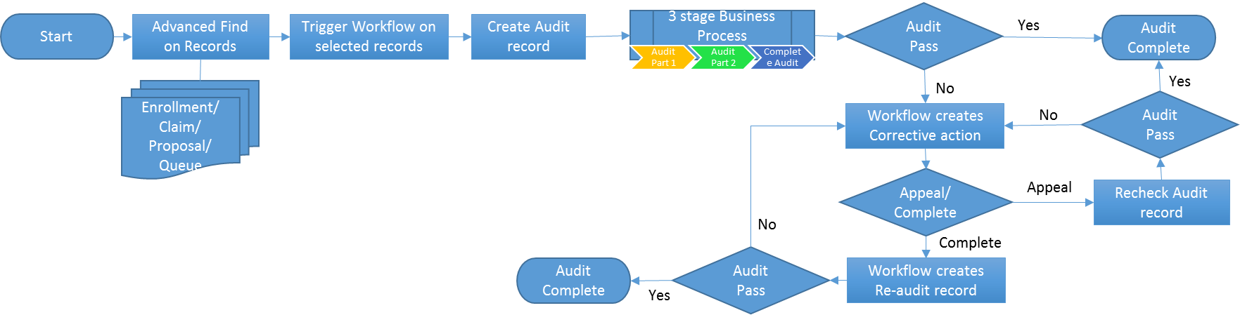

Figure : QA Audit Process

#### Technical Details

##### Workflows

* On Demand workflow creates Audit record from Advanced find view
* Workflow triggered to create Corrective Action record on change of status to ‘Fail’
* Workflow triggered On change of the Corrective action to ‘Complete’, to create a Re-audit record

### Compliance Management

The Compliance team manages the compliance requirements for users that are setup as Property and Casualty Agents as well as the Denial Reasons used in claims.

#### Agents

Some users that sells some of AWE’s programs have to be set up as agents, depending on the state that they sell the programs.

Every agent has three possible licenses:

* State they reside in (for IL or MO)
* License for VA
* License for CA

When a user is identified as an agent, he or she is added to the Agents entity. Training underdone by the agents in tracked in the system. Once the license exam is passed, the Agent gets the Agent Number and becomes active.

##### Licenses

Licenses can then be added under the Agent License sub-grid. Each license has a checklist of items that are added as fields to a stage in the business process flow form. Licensed are entered by state and need to be renewed every 3 years. Renewed licenses are entered as new license records.

### Denial Reasons

Denial reasons are used when a claim is denied. Each record provides the terms and conditions for the denial as well as the reason. They have expiration date, effective date, and can be set to Active or Draft. On expiration date, the denial reason becomes no longer valid.

Denial reasons will populate the terms and conditions of the claim for Denial Claims.

# Build and Deployment Process

## AWE Database and AWE Integration Deployment

The below process is followed to build Evolution_Staging (Database) Project, Evolution_Integration (Database), and AWE Integration (SSIS) Project followed by deploying the Evolution_Staging (Database) Project, Evolution_Integration (Database), and AWE Integration (SSIS) Project into Test Environment from Dev Enviornment.

### TFS Location

TFS is located on this URL:

<http://ame001-tfssc01.ame001.americanwaterservices.com:8080/tfs/Evolution/Evolution/>

Below is the screenshot for reference to the path for solutions

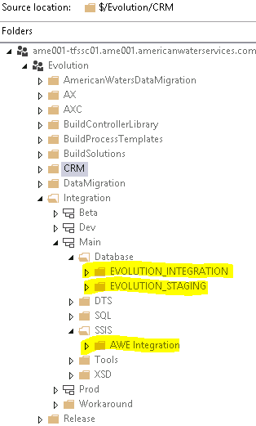

Get the latest version of the solution before starting with build and deployment.

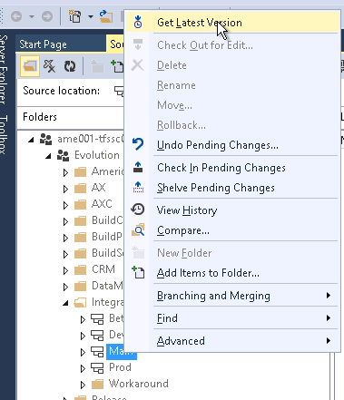

### Steps to be followed for builiding the Evolution_Staging Database

Step 1: Open the Evolution_Staging solution in visual studio from below location mentioned in screenshot.

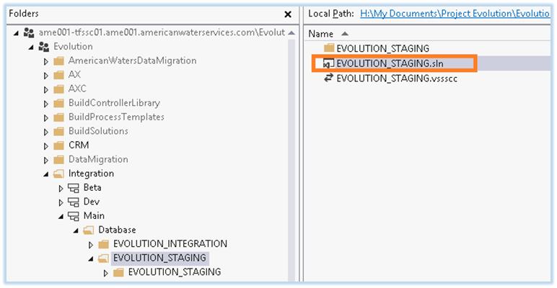

Step 2: Set the visual studio to build the solution in release mode.

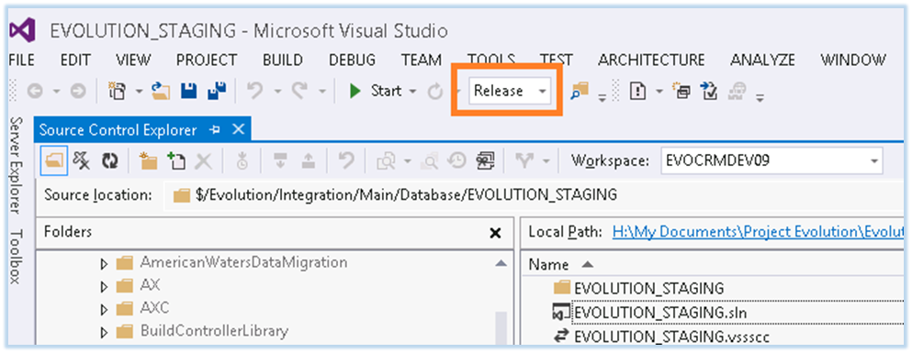

Step 3: Navigate to Evolution_Staging solution and right click on the project, click on build.

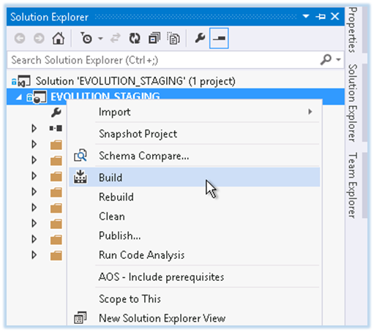

Step 4: Ensure the build is successful.

Step 5: Navigate to **bin>>Release** in Evolution_Staging. **Evolution_Staging.dacpac** is the compiled package which will be used for deployment of Evolution_Staging database project.

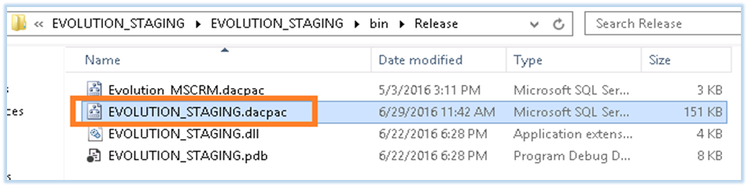

### Steps to be follwed for building the Evolution_integration database

Step1: Open the Evolution_Staging solution in visual studio from below location mentioned in screenshot.

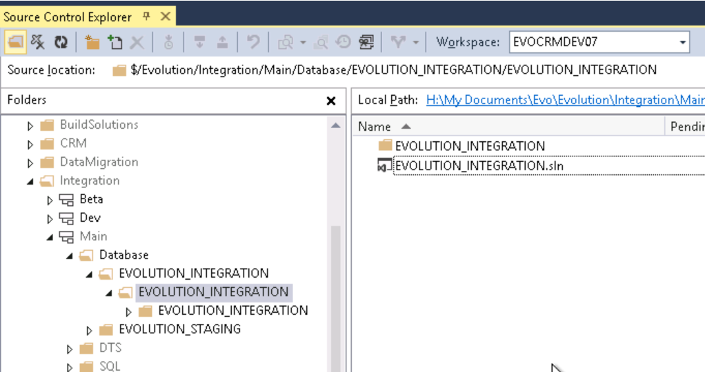

Step2: Set the visual studio to build the solution in release mode.

Step3: Navigate to Evolution_Integration solution and right click on the project, click on build.

Step4: Ensure the build is successful.

Step5: Click on the local path in visual studio and it will open the local Evolution_Integration Project folder where this project resides:

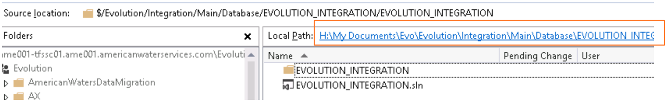

Step6: Navigate to **bin >> Release** folder inside Evolution_Integration folder. **Evolution_Integration.dacpac** is the compiled package which will be used for deployment of Evolution_Integration database project: 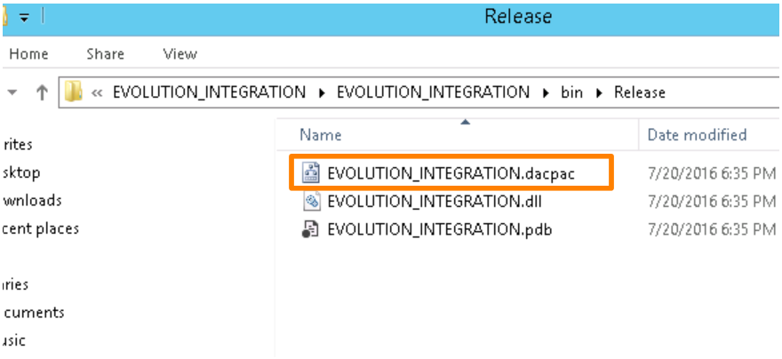

### Steps to be followed for builiding the AWE Integration Project

Step1: Navigate to AWE Integration project under SSIS and SSIS folder in TFS and open the folder in file explorer, by clicking on the mapped folder location:

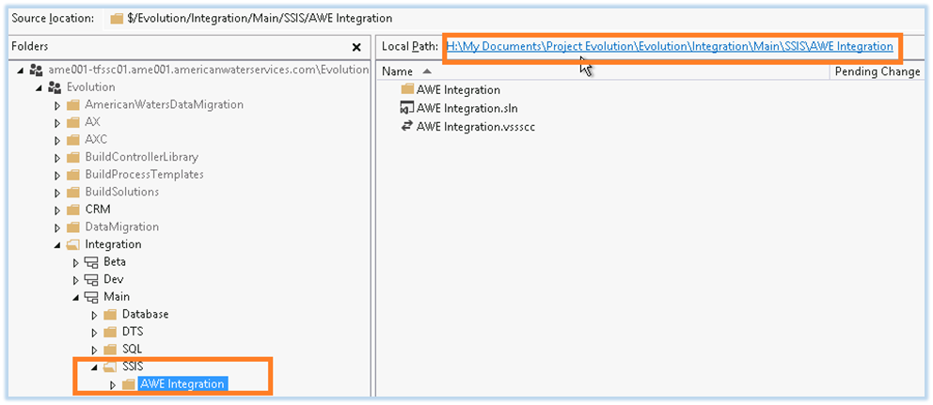

Step2: Right Click on AWE Integration.sln file and open with Microsoft Visual Studio 2010: The DTSX packages of SSIS are compatible with Visual studio 2012 and should be opened with Visual studio 2010.

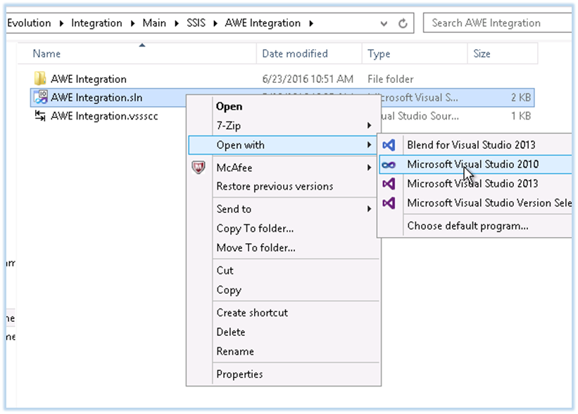

Step3: Right click on the project and goto configuration properties. Set Run64BitRuntime to True.

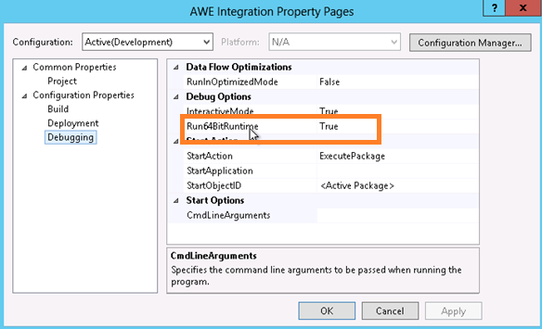

Step 4: Build AWE Integration Solution.

Step 5: Ensure the Build is successful.

Step 6: Navigate to AWE Integration >> bin >> Development. AWE Integration.ispac is used for deployment.

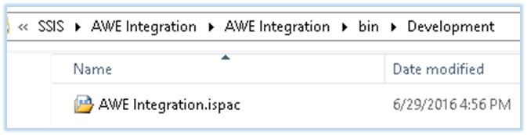

### Deployment of Database and SSIS Packages

Step1: Through the Scribe Console, go to the Integration Processes and pause the jobs named EXT017_Re_EnrollmentsCreation, EXT036- Active Enrolment Expires.

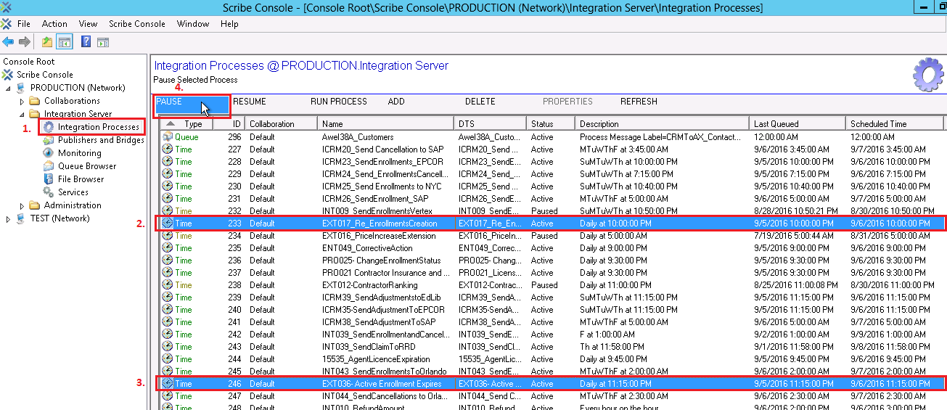

Step2:

* To Move file from development server to test Server you can go to file explorer and in the address bar type in the path for that server as:

**Test**: Database & SSIS - \\evoscribenp01\C$\Users\Public\Documents\Deploy\BI Deploy

**Prod:**

* Database/dacpac - \\ame001-scribe01\c$\users\public\Public Documents\Deploy\BI Deploy (for db - dacpac and Scribe - dts)
* SSIS/ispac - \\ame001-sqldb03\c$\Users\Public\Documents\Deploy\BI Deploy (for SSIS - ispac)

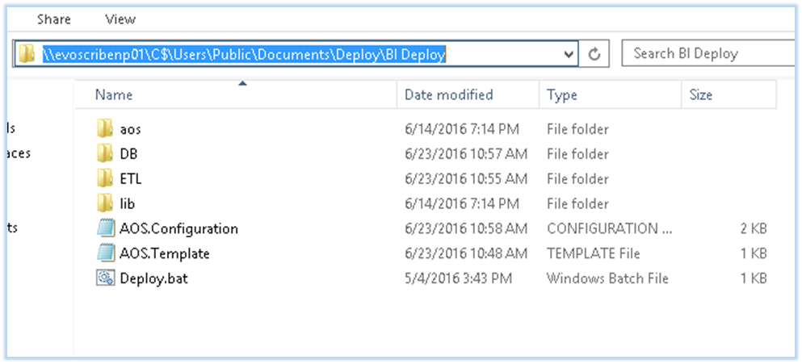

Step3:

* Copy Evolution_Staging.dacpac and/or Evolution_Integration.dacpac file(s) which was generated in the last step of building Evolution_Staging/Evolution_Integration (Database) project and paste in DB folder.
* Copy AWE Integration.ispac file which was generated in the last step of building AWE Integration (SSIS) project and paste it in ETL folder.

Step 4:

Login to EVOSCRIBENP01 (Test) or AME001-SCRIBE01 (Prod - database) or AME001-SQLDB03 Prod (Prod - SSIS) Server via Remote Desktop Connection

Step 5:

Navigate to C:\Users\Public\Documents\Deploy\BI Deploy folder and double click on Deploy.bat file. A Command Prompt window pops up and starts to show the progress of deployment. As soon as the deployment is over we get the success message. Below is a sample image with command prompt output from latest deployment on one of development environments.

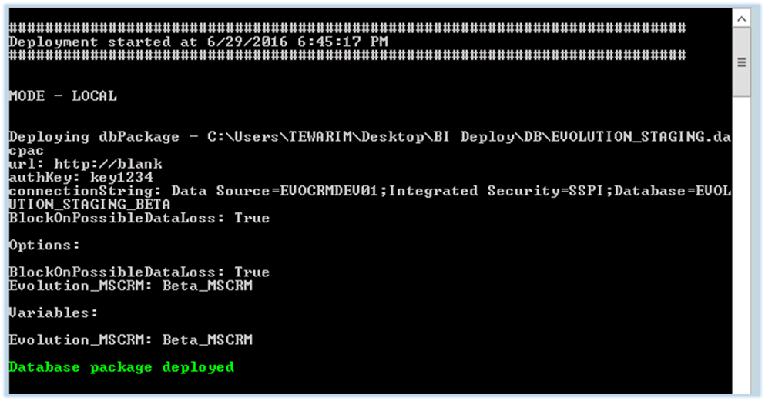

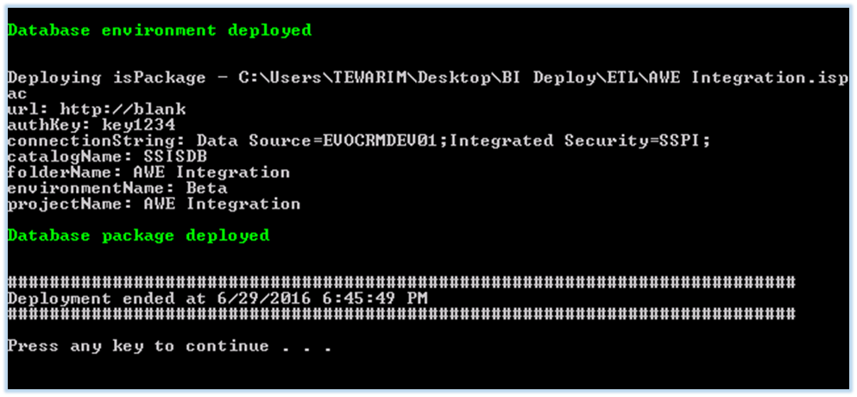

Step 6:

Through the Scribe Console, go to the Integration Processes and resume the jobs named EXT017_Re_EnrollmentsCreation, EXT036- Active Enrollment Expires. These jobs were paused in this section, before we began with the Deployment steps.

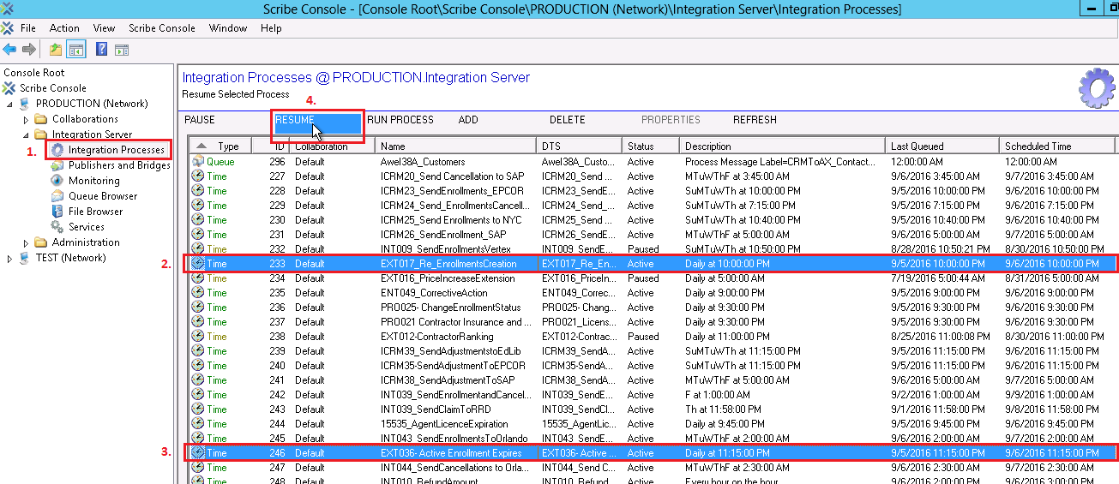

## AWE Scribe DTS Deployment

Step1: Through the Scribe Console, go to the Integration Processes and pause the jobs named EXT017_Re_EnrollmentsCreation, EXT036- Active Enrollment Expires.



Step 2: Copy DTS.zip and CRM.zip to \\evoscribenp01\C$\Users\Public\Documents\Deploy\Scribe, and extract DTS folder and CRM folder from respective zip files and then delete zip files so that the deployment folder looks like

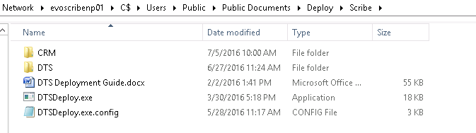

**Additional Information**: DTS Folder contains folders and DTS files with name exactly same as what we have in Scribe Working directory on any of the Scribe Environments, like:

* Test : \\evoscribenp01\c$\Users\Public\Documents\Scribe\Collaborations\Default
* Prod: \\ame001-scribe01\c$\Users\Public\Documents\Scribe\Collaborations\Default

Folders in working directory are in sync with the DTS TFS folder structure in the TFS branch

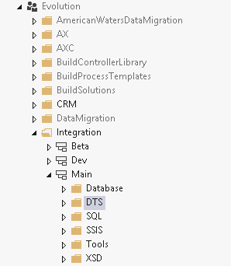

CRM Folder contains any or all of the folders as shown below for which we need to update the .ini/.cfg files.

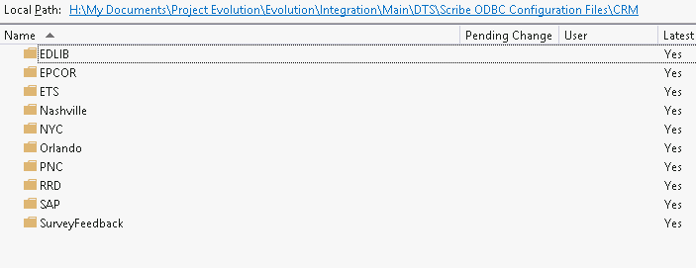

Step 3: Open the DtsDeploy.exe.config just to make sure it points to test environment. The settings should look like-

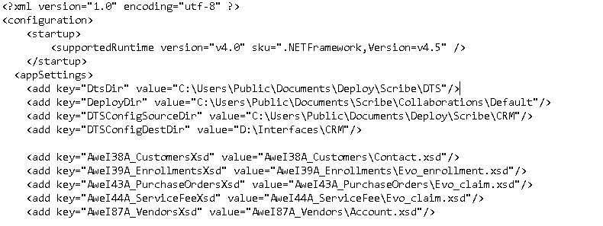

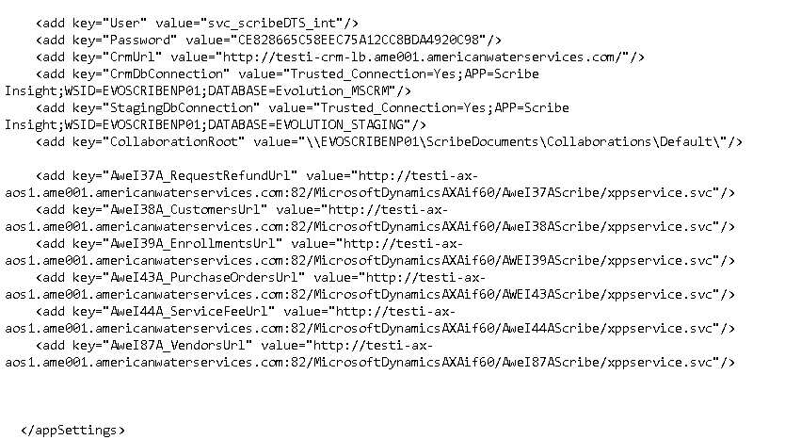

**The configuration file on each environment and respective TFS branch contains setting as per what is needed for the deployment on that environment.**

Step 3: Double click on DTSDeploy.exe and a Menu will be presented with 3 options.

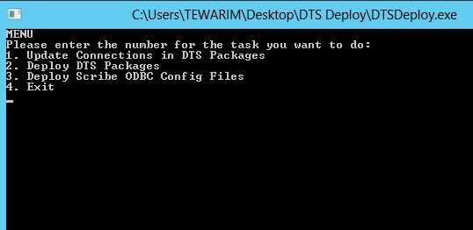

Step 4:

After we Press “1” and hit Enter it then gives the message “You are about to update connection details for dts packages located in source directory (Dtsdir)” and asks “Would you like to continue? (Y/N)”.

Once we press “Y” and hit Enter, it then updates the connection string in all the DTS packages.

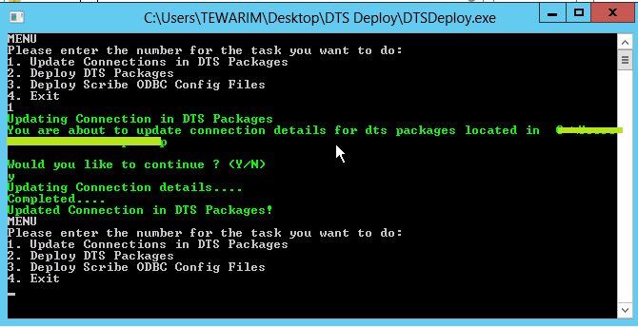

Step 5:

After all the Connection details are updated it then again presents the Menu. Now we need to select the option 2 to get the packages deployed in the destination location. For this we press “2” and then hit Enter. We can then see that it first says “Deploying DTS Package” and once it done copying all the files it then gives the message “DTS Package Deployed!”

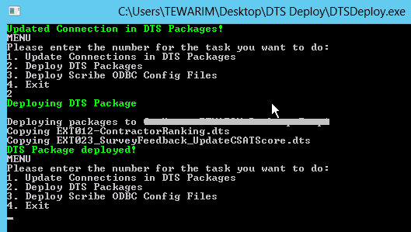

Step 6:

After, the packages are deployed to the Source location we then need to update the Scribe Configuration Files by using the option 3. Once we press “3” and hit Enter it gives the message   
“Deploying Scribe ODBC Config Files” and once done it then gives the message “Scribe ODBC Config Files Deployed!”

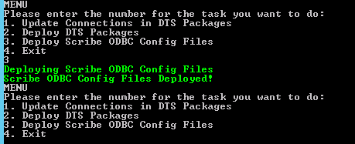

Step 7:

Randomly select DTS packages under D:\Scribe\Collaborations\Default\CRM and verify that the file opens. Also, verify that the modified on date & time of file is shown as current time “file modified date.”

Step 8:

Through the Scribe Console, go to the Integration Processes and resume the jobs named EXT017_Re_EnrollmentsCreation, EXT036- Active Enrollment Expires. These jobs were paused in this section, before we began with the DTS Deployment steps.

## CRM 2013 deployment

Moving customizations to config Environment

Step 1: Login to <http://evoaxprj01.ame001.americanwaterservices.com:5555/NewConfig/main.aspx> with admin credentials. Goto settings>>solutions>> EvolutionConfigsolution

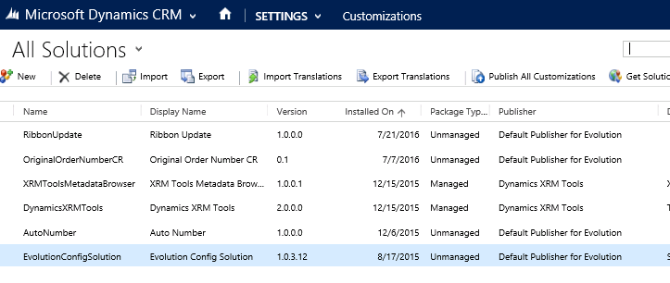

Step 2: Do the customizations manually in the above said solution and publish the changes.

Step 3: Update the version and defect/gap info and publish changes.

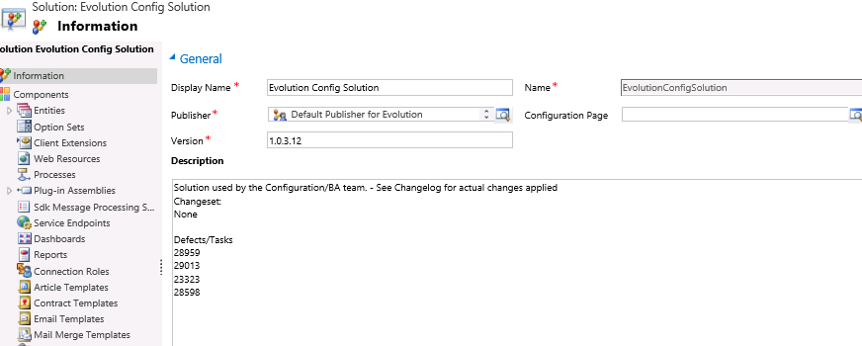

Moving Configuration changes to NewMasterConfig

Step1: Login to <http://evoaxprj01.ame001.americanwaterservices.com:5555/NewMasterConfig/main.aspx> with admin credentials.

Step2 : Run the sync tool to get master data for configuration from Beta and put in NewMasterConfig

Step3 : Run the sync tool to get master data for configuration from NewMasterConfig to different CRM

Step4 : Verify the newly created records from source in Test CRM

## Support Process

Stage 1: Defects are assigned to developer.

Stage 2: Developer does the analysis and do the code changes in his/her Dev box.

Stage 3: Developer shelves the changes into Beta Branch, notes the shelve number and updates the Defect with shelve number.

Stage 4: All the shelved changes are then checked into Beta branch and change set numbers are updated in respective defects.

Stage 5: Deployment to Beta environment <http://evocrmdev01.ame001.americanwaterservices.com:5555/Beta/main.aspx> .Please refer sections 4.1 to 4.3 of this document for deployment process.

Stage 6: Beta environment is tested for the defects. If the test fails then the defect is assigned back to developer.

Stage 7: After successful testing, code merge to Dev branch from Beta branch. Change set numbers are noted for all the defects.

Stage 8: Deployment to Dev environment <http://evocrmdev01.ame001.americanwaterservices.com:5555/Evolution/main.aspx> . Please refer sections 4.1 to 4.3 of this document for the deployment process.

Stage 9: After successful testing, code merge to Main branch from Dev branch. Change set numbers are noted for all the defects.

Stage 10: Once the main branch is merged with latest changes, Release folder has to be created. Release folder contains all the deployable files. All the applicable solution files are compiled in release mode and the executable files are copied into a folder in release folder. Name of the folder will be date (“mm/dd/yyyy”) of the building the solution. Folder should be checked in under Release>>CRM after GO live

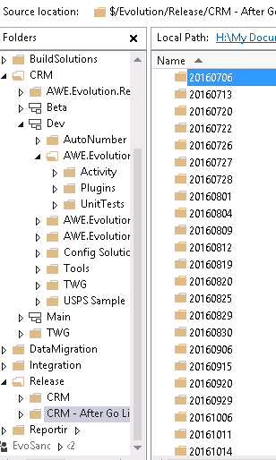

Sample contents of the release folder.

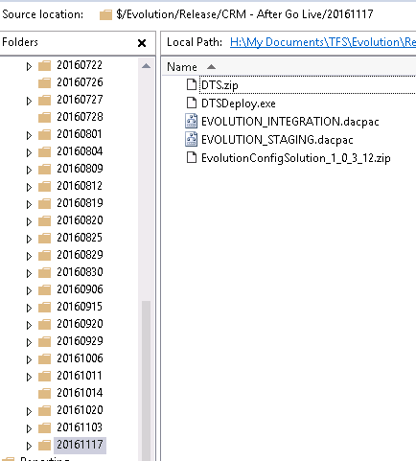

Stage 11: AWE team should be notified with the release folder details and release notes.

# Test Environment

## Testing tools

Covered in section ***Non-Production Environment***

## Integration Test Environment

### Expected Capacity

The Integration Test environment shall support up to 40 users from the joint AWE and Avanade Project Evolution team and an Avanade Test team dedicated to Project Evolution.

### Design Approach

The Integration Test environment is architecturally identical to the Production environment with only be one server in each role in the Presentation and Application tiers. In the Data tier, one SQL Server shall host all databases and the SQL Server Analysis, Integration and Reporting Services (SSAS, SSIS & SSIS respectively).

### Conceptual and Logical Architecture



Figure : Integration Test Environment - Conceptual Infrastructure



Figure : Integration Test Environment - Logical Infrastructure

### Specifications



Table : Specifications of Test Environment

# Important System Characteristics

## Transaction Volume and Data Volume

** This is to be determined during Secondary and Primary support phases **

## Job Scheduling/Sequencing of Batch Jobs

### Overview

Below is an overview of all the scheduled integrations and any batch job currently in place at AWE.

#### Scribe-based Integrations

|  |  |  |
| --- | --- | --- |
| S No | Scribe DTS | Description |
| File based Scribe Processes | | |
| 1 | INT013_LockBox | Processes the Lock box csv file and updates the CRM staging DB |
| 2 | ICRM66_ProcessShutoffsfromVertex | These DTS packages will get the cancelled enrolments from the respective third parties and updates the CRM |
| 3 | ICRM65_ProcessShutoffsfromSAP |
| 4 | ICRM64_ProcessShutoffsfromNYC |
| 5 | ICRM63_ProcessShutoffsfromNashville |
| 6 | ICRM62_ProcessShutoffsfromEPCOR |
| 7 | INT045_ProcessShutoffsfromOrlando |
| 8 | INT064_HOS5_Orlando_Enrolment_Response | Updates the enrollment with enrollment response file coming from Orlando. |
| 9 | INT064_HOS5_Orlando_Cancellation_Response | Updates the enrollment with cancellation response file coming from Orlando. |
| 10 | INT063_HOS5_Edlib_Adjustment_Response | Updates the adjustment with adjustment response file coming from Edlib. |
| 11 | INT063_HOS5_Edlib_Cancellation_Response | Updates the enrollment with cancellation response file coming from Edlib. |
| 12 | INT062_HOS5_EPCOR_Adjustment_Response | Updates the adjustment with adjustment response file coming from EPCOR. |
| 13 | INT062_HOS5_EPCOR_Cancellation_Response | Updates the Enrolment with cancellation response file coming from EPCOR. |
| 14 | INT060_HOS5_SAP_Adjustment_Response | Updates the adjustment with adjustment response file coming from SAP. |
| 15 | INT060_HOS5_SAP_Cancellation_Response | Updates the enrollment with cancellation response file coming from SAP. |
| 16 | INT060_HOS5_SAP_Enrolment_Response | Updates the enrollment with enrollment response file coming from SAP. |
| 17 | INT059_HOS5_NYC_RESPONSE | Updates applicable enrollments, cancellation, adjustments of NYC Customers with response file |
| 18 | ICRM50_Nashville_Prospects | Imports Customer records from StagingCRM.NashvilleProspect to CRM DB |
| 19 | ICRM51_NYC_Prospects | Imports Customer records from StagingCRM.NYCProspect to CRM DB |
| 20 | ICRM52_SAP_Prospects | Imports Customer records from StagingCRM.SAPProspect to CRM DB |
| 21 | INT042_Orlando_Prospects | Imports Customer records from StagingCRM.OrlandoProspect to CRM DB |
| Queue based Scribe processes | | |
| 22 | Awei39A_Enrollments | CRM to AX enrolment update |
| 23 | Awei44A_ServiceFee | CRM to AX Claim service fee status update |
| 24 | Awei87A_Vendors | CRM to AX Contractor update |
| 25 | Awei38A_Customers | CRM to AX contact update |
| 26 | Int026_ApproveContractor | Ax to CRM Contract approval |
| Time based Scribe Processes | | |
| 27 | ICRM20_Send CancelationtoSAP | Daily at 11:55 PM |
| 28 | ICRM23_Send EnrolmentstoEPCOR | Daily at 10:35 PM |
| 29 | ICRM24_Send Enrolments Cancelations_Nashville | Daily at 11:25 PM |
| 30 | ICRM25_SendEnrolmentstoNYC | Daily at 11:20 PM |
| 31 | ICRM26_Send EnrolmentstoSAP | Daily at 11:10 PM |
| 32 | INT009_SendErolmentstoVertex | Daily at 12:00 AM |
| 33 | EXT017_Re_EnrolmentCreation | Daily at 10:00 PM |
| 34 | Contractor Insurance and License Compliance Alerts | Daily at 10:40 PM |
| 35 | EXT012_Contractor Ranking | Monthly on day 31 at 9:05 PM |
| 36 | ICRM39_Send Adjustments to Edlib | Daily at 8:40 PM |
| 37 | ICRM35_Send Adjustments to EPCOR | Daily at 9:35 PM |
| 38 | ICRM38_Send Adjustments to SAP | Daily at 9:40 PM |
| 39 | INT039_SendEnrolmentsandCancelationstoRRD | Daily at 8:40 PM |
| 40 | INT039_SendClaimtoRRD | Daily at 11:58 PM |
| 41 | INT043_SendEnrolmentstoOrlando | Daily at 11:05 PM |
| 42 | INT044_SendCancelationstoOrlando | Daily at 11:55 PM |
| 43 | INT_010_RefundAmount | Every hour |
| 44 | INT039_SendMarketingListtoRRD | Daily at 12:00 PM |

Table : Scribe-based Integrations

#### Stored Procedures in use

|  |  |  |  |
| --- | --- | --- | --- |
| S No | Operation | Stored Procedure | Description |
| 1 | Deliquency | sp_aweContactDelinquency | To compare AX and CRM contacts and find deliquent ones in CRM |
| 2 | Deliquency | sp_aweEnrollmentDelinquency | To compare AX and CRM enrollment and find deliquent ones in CRM |
| 3 | Deliquency | sp_aweContactMonthlyCancellation | To compare AX and CRM contacts and find monthly cancellation ones in CRM |
| 4 | Deliquency | sp_aweEnrollmentMonthlyCancellation | To compare AX and CRM contacts and find monthly cancellation deliquent ones in CRM |
| 5 | Deliquency | sp_aweContactNonDelinquency | To compare AX and CRM contacts and find non deliquent ones in CRM |
| 6 | Deliquency | sp_aweEnrollmentNonDelinquency | To compare AX and CRM contacts and find non deliquent ones in CRM |
| 7 | Propsect Migration | StagingCRM.sp_aweGetProspectNashville | This SP will compare CRM data and New data from Nashville and decide whether to update or create in CRM |
| 8 | Propsect Migration | StagingCRM.sp_aweGetNYCProspect | This SP will compare CRM data and New data from NYC and decide whether to update or create in CRM |
| 9 | Propsect Migration | StagingCRM.sp_aweGetOrlandoProspect | This SP will compare CRM data and New data from Orlando and decide whether to update or create in CRM |
| 10 | Propsect Migration | StagingCRM.sp_aweGetRRDProspect | This SP will compare CRM data and New data from RRD and decide whether to update or create in CRM |
| 11 | Propsect Migration | StagingCRM.sp_aweGetSAPProspect | This SP will compare CRM data and New data from SAP and decide whether to update or create in CRM |
| 12 | Lockbox | StagingCRM.sp_aweGetLockboxStagingToCRM | This SP will read file from Lock Box and decide whether to create new or problem enrollment in CRM , renew old enrollment |
| 13 | Refund | StagingCRM.sp_aweSendRefundToAX | This SP picks up adjustment thar are directly associated to customer w/o enrollment and send them to AX |
| 14 | Contractor Ranking | StagingCRM.sp_awePopulateContractorRanking | This SP will calulate ranking and create ranking record for contractors |
| 15 | Avearge claim cost | StagingCRM.sp_aweSetAverageCostStagingToCRM | This SP calulates average claim cost for claims |

Table : Stored Procedures in Use

#### SSIS based integrations

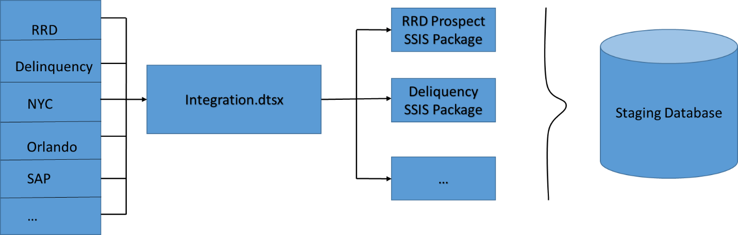

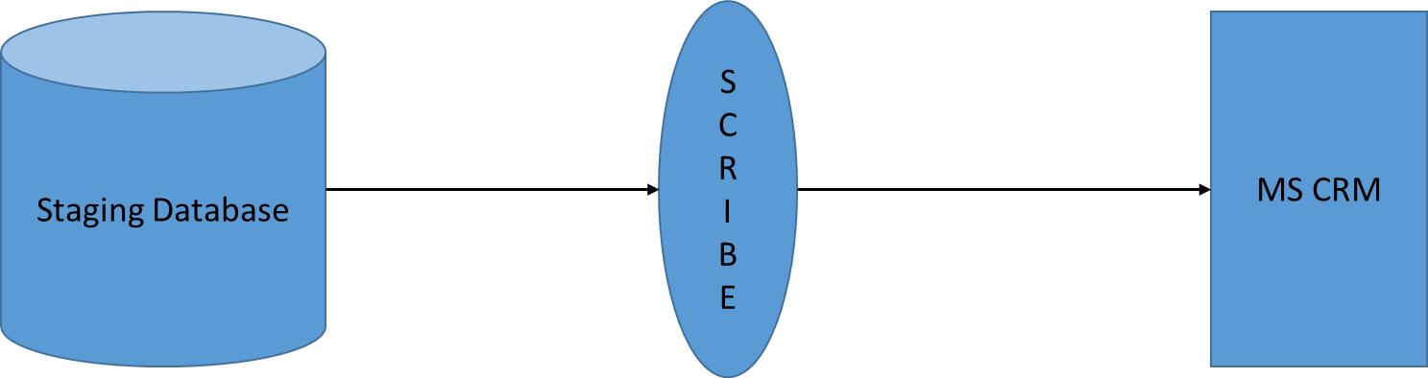

*Figure 37: SSIS Integration*

|  |  |  |
| --- | --- | --- |
| SSIS package | | Description |
| ProcessFiles.dtsx | The ProcessFiles.dtsx package is responsible for reading the input file, make the preliminary validations on the data present in the file and is used to move the data in the file to the respective prospect tables for further processing.  This process takes the Integration ID and the Record Source as the input parameters. | |
| RefreshStaticData.dtsx | The RefreshStaticData.dtsx is the package which is used to get all the static data required from the CRM database in order to do the comparison at run time with the data which we receive from various 3rd party systems. | |
| ProspectLoadFromCRM.dtsx | The ProspectLoadFromCRM.dtsx is the package which is used during the Prospect Import, where the data from the Prospect Master table for respective prospects is fetched from the Evolution Staging database. This is needed in order to identify whether the record sent by the 3rd party is a new record or an existing record to decide the action to be performed on CRM. | |
| GetDelinquentDataFromAXAndCRM.dtsx | The GetDelinquentDataFromAXAndCRM.dtsx is used to fetch the data from staging tables in AX and then populates the delinquency details in the respective enrollment and Customer tables.This package is specific for delinquencies. | |
| ExecuteScribeWorkbench.dtsx | The ExecuteScribeWorkbench.dtsx is used to launch multiple instances of scribe DTS for a particular scribe type executable based on the value of the modulus. | |
| RRDProspectLoadFromCRM.dtsx | The RRDProspectLoadFromCRM.dtsx is specifically used only to fetch the Prospect Master details for the RRD 3rd Party system. | |
| RetryFallout.dtsx | The RetryFallOut.dtsx check the records which are logged in the error log tables corresponding to the respective Scribe DTS after the DTS execution and if they errored records have valid error messages configured in ErrorMessages table. The records with valid error messages are picked up and the DTS is executed to process the records again.  The number of times the retry has be executed is defined in the integration table.  The integration name is taken as parameter for this package. | |
| EnableDisablePlugin.dtsx | The EnableDisablePlugin.dtsx is used to enable or disable a plugins related to the entities used by the integration. The plugins are disabled before the execution and are enabled back after the execution.  This package takes the Integration ID as the parameter. | |
| GeneratesFalloutRecordFile.dtsx | The GeneratesFalloutRecordFile.dtsx uses a console application to write the failure records into a fall out file located at a path defined in the file detail record.  This takes the Record source and integration ID as parameters. | |
| Integration.dtsx | The Integration.dtsx is the primary package in which the flow has been defined to execute all the steps associated with an integration in the defined order. This will be using the rest of the dtsx packages along with additional steps to complete the flow.  The flow is as mentioned below:  The executables associated with the Integration are fetched.  There are 3 types of executables:  Scribe  SSIS  Batch  There are process Integrations defined for each Integration along with the executable id and run order which defines which script will be executed.  The details of the executable are logged before and after the execution to maintain the logs for each execution via this package.  This package takes the integration id as the input parameter. | |

Table : SSIS based integrations

##### Major tables in use by SSIS integrations

|  |  |  |  |
| --- | --- | --- | --- |
| Sr No | Operation | Tables | Use |
| 1 | Execute Integration.dtsx | load.Integrations | Get Integration Id for job |
| 2 | Execute Integration.dtsx | load.Executables , load.ProcessIntegration | Get list of executables for that integration id |
| 3 | Execute Integration.dtsx | LoadStatus | Logging table |
| 4 | Execute Integration.dtsx | ServerConnectionDetail , ScriptsType ,ProcessInterationScripts , ProcessIntegration ,Integrations | Get pre load script for a particular executable |
| 5 | Execute Integration.dtsx | ServerConnectionDetail , ScriptsType ,ProcessInterationScripts , ProcessIntegration ,Integrations | Get post load script for a particular executable |
| 6 | Read Third Party File | load.FileDetail , load.SupportedFileType , Setup.Entity , load.ServerConnectionDetail | Used to get information of file from third party |
| 7 | Read Third Party File | ErrorLog.ProspectFileProcessing | Used to log error occurred in above process |
| 8 | Load CRM prospect into staging | StagingCRM.tmpNashvilleProspectMASTER | Used to store latest CRM prospect data for Nashville |
| 9 | Load CRM prospect into staging | StagingCRM.tmpNYCProspectMASTER | Used to store latest CRM prospect data for NYC |
| 10 | Load CRM prospect into staging | StagingCRM.tmpOrlandoProspectMASTER | Used to store latest CRM prospect data for Orlando |
| 11 | Load CRM prospect into staging | StagingCRM.tmpRRDProspectMASTER | Used to store latest CRM prospect data for RRD |
| 12 | Load CRM prospect into staging | StagingCRM.tmpSAPProspectMASTER | Used to store latest CRM prospect data for SAP |
| 13 | Deliquency | StagingCRM.AXDeliquencyStage | Used to store AX deliquency information |
| 14 | Deliquency | CRM.EvoEnrollment | Used to store latest CRM enrollement data |
| 15 | Deliquency | CRM.EvoCustomer | Used to store latest CRM customer data |

Table : Tables used by SSIS Integrations

### Integrations with Third Parties

#### Prospects from Third Parties

The prospects list from different 3rd parties are processed by SSIS dtsx package. “**ProcessFiles.dtsx**”

The 3rd parties are as below:

1. *Nashville*
2. *NYC*
3. *Orlando*
4. *RRD*
5. *SAP*

The list of customers to be processed are stored in the CRM staging database in the prospect tables respectively as below

1. *StagingCRM.NashvilleProspect*
2. *StagingCRM.NYCProspect*
3. *StagingCRM.OrlandoProspect*
4. *StagingCRM.RRDProspect*
5. *StagingCRM.SAPProspect*

The **ProspectLoadFromCRM.dtsx** will get the data from the Prospect Master table of Evolution Staging database. This is needed in order to identify whether the record sent by the 3rd party is a new record or an existing record to decide the action to be performed on CRM.

Below is the list of master prospect tables.

1. *StagingCRM.tmpNashvilleProspectMASTER*
2. *StagingCRM.tmpNYCProspectMASTER*
3. *StagingCRM.tmpOrlandoProspectMASTER*
4. *StagingCRM.tmpRRDProspectMASTER*
5. *StagingCRM.tmpSAPProspectMASTER*

Below is the list of stored procedures used to compare data in prospect and prospect master table.

1. *StagingCRM.sp_aweGetProspectNashvilleDelta*
2. *StagingCRM.sp_aweGetNYCProspectDelta*
3. *StagingCRM.sp_aweGetOrlandoProspectDelta*
4. *StagingCRM.sp_aweGetRRDProspectDelta*
5. *StagingCRM.sp_aweGetSAPProspectDelta*

The Stored procedures will compare and match the prospect records in two tables such as Prospects and Prospects Master table for each 3rd party respectively. If there is a match found, the ***Update*** action is triggered. If there is no match, the ***Create*** action will be triggered.

Below mentioned scribe DTS Packages will read the prospects from the prospect tables in staging and creates Customers in CRM:

**Scribe DTS packages**

1. *INT042_Orlando_Prospects*
2. *ICRM50_Nashville_Prospects*
3. *ICRM52_SAP_Prospects*
4. *ICRM51_NYC_Prospects*

Below is the control flow diagram of **ProspectLoadFromCRM.dtsx** package

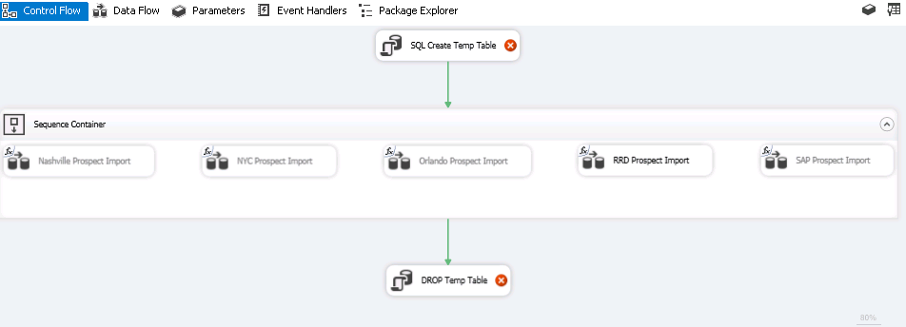

##### Execution order of integrations and Plugins

1. ProcessFiles.dtsx
2. ProspectLoadFromCRM.dtsx
3. EnableDisablePlugin.dtsx
4. RefreshStaticData.dtsx
5. ExecuteScribeworkbench.dtsx ( in case of premise update the respective scribe DTSX can be called- this is dependent on the 3rd party whether the premise details are sent or not)
6. RefreshStaticData.dtsx
7. ExecuteScribeWorkbench.dtsx ( multiple DTS can be configured for inserts/updates based on the files sent from Third Party)
8. EnableDisablePlugin.dtsx

#### Enrollments to Third Parties

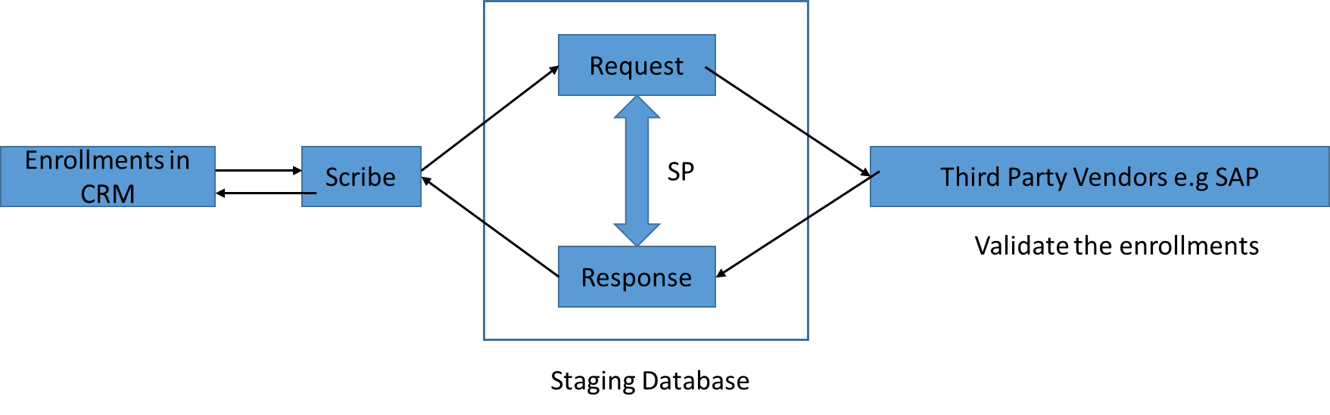

Enrolments that are created in CRM needs to be validated by third parties. Enrollment with active status are picked by a scribe DTS that runs daily. The Scribe job will copy CRM enrollment data in to request table that needs to be validated. This data is validated and sent as response back to response table.

Enrollments are sent to SAP, NYC, EPCOR, Vertex, and Orlando.

A Stored Procedure is written that compares this request and response and generates input that will be read by scribe DTS. If some enrollments are missing in response they are updated likewise in CRM.

* For Error enrollments, enrollments are updated with status reason HOS exception. A workflow then triggers that picks up such records and put in HOS exception queue.
* Same procedure for Adjustment & cancellation records as well.  
  This entire operation of sending data from CRM to third party and then getting response and updating back in CRM is managed by below DTS packages.

CRM to third party DTS :

* ICRM23_Send CancelationtoSAP
* ICRM20_Send EnrolmentstoEPCOR
* ICRM24_Send Enrolments Cancelations_Nashville
* ICRM25_SendEnrolmentstoNYC
* ICRM26_Send EnrolmentstoSAP
* INT009_SendErolmentstoVertex
* ICRM39_Send Adjustments to Edlib
* ICRM35_Send Adjustments to EPCOR
* ICRM38_Send Adjustments to SAP
* INT039_SendEnrolmentsandCancelationstoRRD
* INT043_SendEnrolmentstoOrlando
* INT044_SendCancelationstoOrlando

Third party to CRM DTS :

* INT064_HOS5_Orlando_Enrolment_Response
* INT064_HOS5_Orlando_Cancellation_Response
* INT063_HOS5_Edlib_Adjustment_Response
* INT063_HOS5_Edlib_Cancellation_Response
* INT062_HOS5_EPCOR_Adjustment_Response
* INT062_HOS5_EPCOR_Cancellation_Response
* INT060_HOS5_SAP_Adjustment_Response
* INT060_HOS5_SAP_Cancellation_Response
* INT060_HOS5_SAP_Enrolment_Response
* INT059_HOS5_NYC_RESPONSE

### RRD Prospects into CRM

RRD Prospect import is similar to that of other 3rd party integrations. Earlier the SSIS package – *RRDProspectLoadFromCRM.dtsx* is used for fetching RRD prospects from CRM, but now this is merged inside *ProspectLoadFromCRM.dtsx.*

### Lockbox integration

The Bank sends a csv file having customer details. The csv file is placed in scribe and scribe updates the staging table. A stored procedure is executed to compare few checks as below.

* Customer existence check.
* Marketing code existence check.

**StagingCRM.sp_aweGetLockboxStagingToCRM** is the stored procedure which serves as a source for Scribe.

#### Conditions in stored procedure

1. Check whether the Customers from lockbox file exists in CRM based on Last Name, ReferenceId, ServiceState
2. Check whether the customers have the same marketing code from file

Stored procedure will fetch enrollments with status active, draft, suspended, expired. If there are two enrollments, then enrollment with max date is picked.

Renewal enrollments or Payment authorization records for payment type as ACH are created for customers. On Creation of Payment authorization, a plugin is triggered to get the payment method and send the data to ETS.

#### Records which can be created after lockbox process

The following can be created from the lockbox process:

* Problem Enrolment

If the customer record is present with bad information in the file a problem enrollment is created for the customer. The problem enrollment is sent to problem enrollment queue, then AW team resolves the issue.

* New Enrolment

If there is no enrollment created for the marketing code and program type, then new enrollment is created.

* Create Renew task and renew the enrollment

If the enrolment returned from CRM has end date > 75 days then a renew task is created to send letter to customer saying that a “Duplicate payment is received”. If end date < 75 days then a renew task is created to send letter saying “AWE received payment for renewal”. In both case renewal will happen.

* Payment Authorization for ACH

If the payment method is ACH then payment authorization with ETS is set up.

The staging table is truncated after the lockbox process.

### Delinquency Integration Process

Data from CRM and Dynamics AX will be fetched using SSIS and put into two tables. A Stored Procedure runs which will basically choose delinquency information to be processed by CRM.

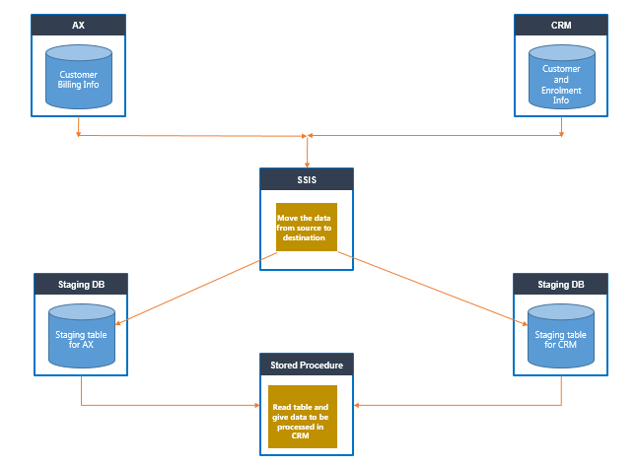

Figure : Delinquency Integration Process

Once the data is processed in the staging tables, Scribe will process the records and create the necessary records in CRM.

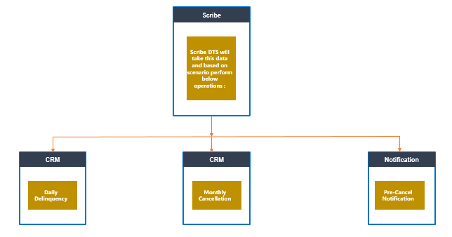

Figure : Scribe processing of Delinquencies

#### Execution order of integrations

* GetDelinquentDataFromAXAndCRM.dtsx
* EnableDisablePlugin.dtsx
* ExecuteScribeworkbench.dtsx (multiple DTS can be configured to call the various DTS files to update the contact, enrollment delinquency and non-delinquency status).
* EnableDisablePlugin.dtsx

### Processing of Shutoffs

High level overview of shut off process

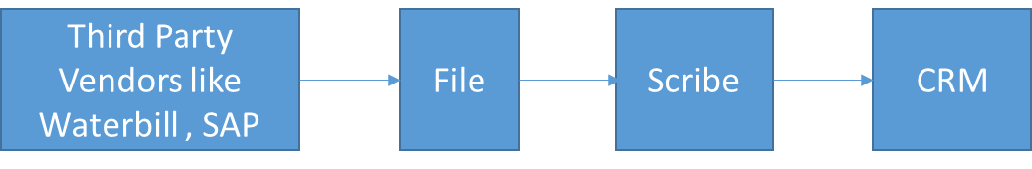

Figure : Shutoff Integration Process

For each third party separate DTS is developed. Each third party will send their list of enrollments to be cancelled and they will be cancelled by respective DTS only.

File will not contain actual enrollment number but will have customer information.

Based on customer, we will find respective enrollments in CRM

Enrollments in CRM have payment method field which explains type of vendor enrollment is associated with.

Based on this scribe DTS will only update those enrollments of a customer.

Scribe DTS files for various 3rd party systems.

* ICRM62_ProcessshutoffsFromNashville
* ICRM62_ProcessshutoffsFromEPCOR
* ICRM62_ProcessshutoffsFromSAP
* ICRM62_ProcessshutoffsFromNYC
* ICRM62_ProcessshutoffsFromVertex

### Integration with Dynamics AX

#### Contractors

The Contractors are integrated in to AX system b on the Create in AX and Update in AX field values.

Workflow : Update Contractor in AX

Whenver certain fields in Contractor is updated the Update in AX field is set by a workflow

Scribe DTS job:

* A Scribe publisher listens to Scribe Queue , and gets the Contractor updated information
* The Scribe dts job updates the contractor information in AX
* In AX system, the Contractors are identified as “Vendors”

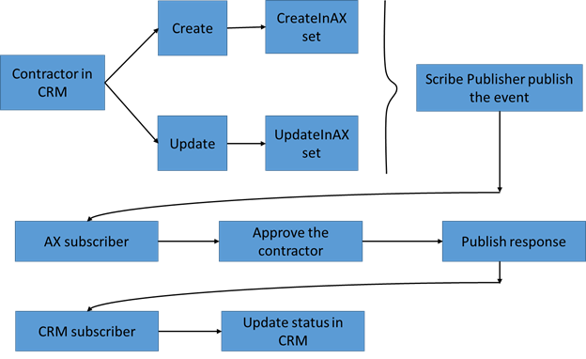

Figure 37: Dynamics CRM to AX Contractor Integration Process

* The contractor status is updated by AX system, and sends the response to CRM
* The Scribe publisher listens to the response and updates the AX status field in CRM based on the response
  + Approved/Rejected/Hold
  + AX Update field is updated with information for eg: Need more information

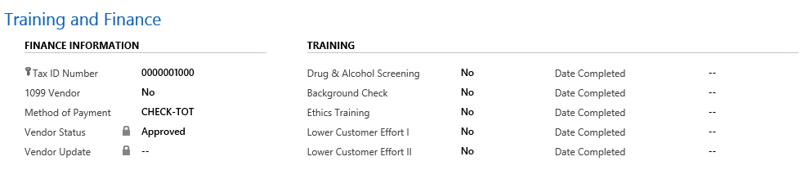

Figure : Section in CRM on the Contractor Form with data from AX

#### Customer , Enrollment and Claims

* When customer/enrollmenr/claim gets created or updated , the event is published using scribe publisher
* AX subscriber listen this event and will process the claim record.
* AX will then publish a response which will be updated back in CRM.
* Respective fields are updated in CRM from AX as shown in below :

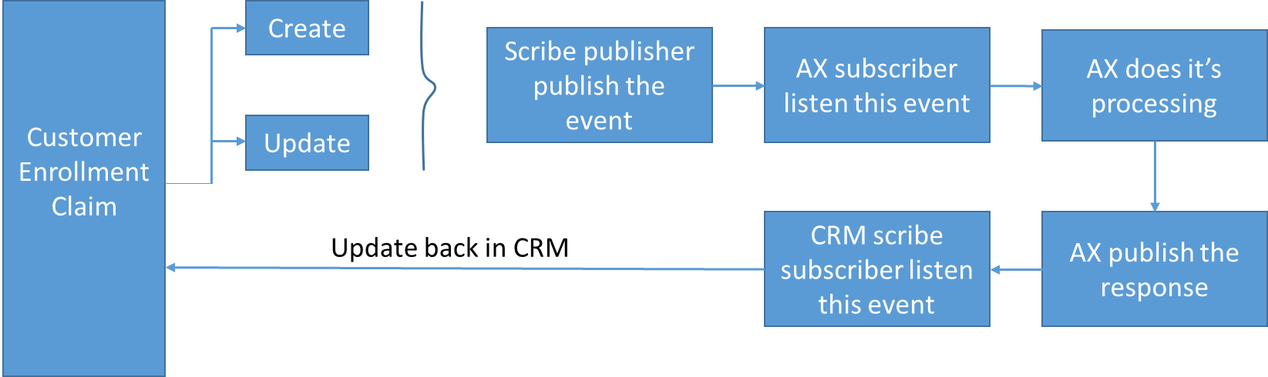

Figure : Integration to AX for Customer, Enrollment and Claims

Below is claim’s screen shot of CRM field that gets updated from AX:

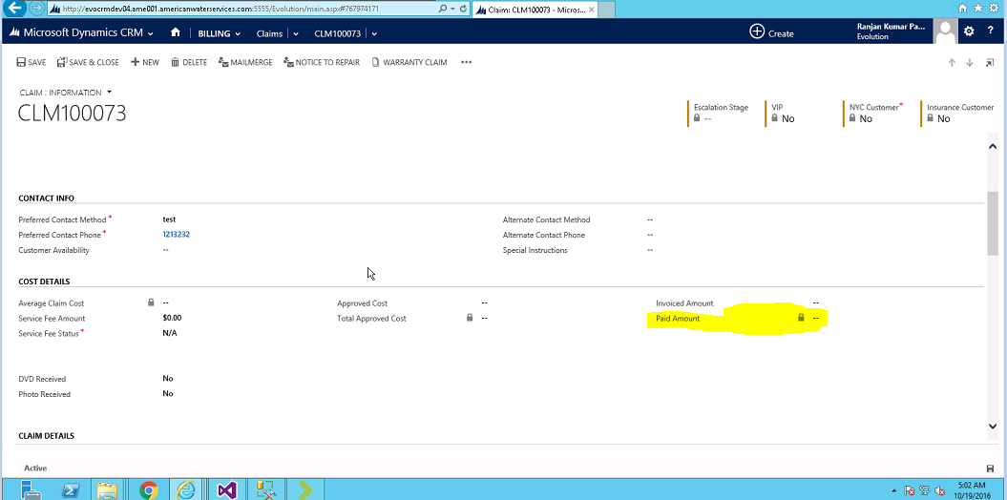

Figure 40: Section in CRM on the Claim Form with data from AX

Scribe DTS for various AX integration with CRM :

* Awei39A_Enrollments
* Awei44A_ServiceFee
* Awei87A_Vendors
* Awei38A_Customers
* Int026_ApproveContractor

### Auto Renewal

Auto renewal is a process of renewing the enrollments that are about to expire.  
It is done by scribe job which is time-based.  
Below are job details :



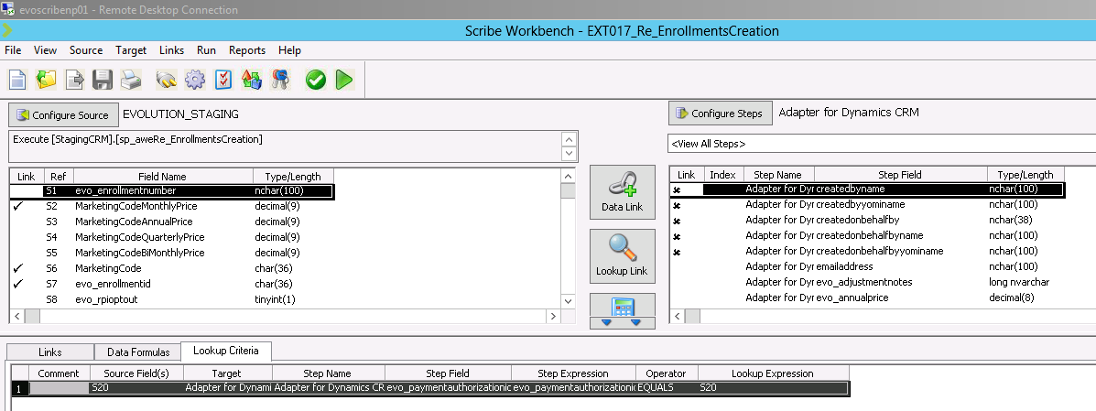

Figure 41: Scribe DTS for auto renewal

This DTS will execute SP called StagingCRM.Sp_aweRe_EnrollmentsCreation.

Major conditions checked for enrollment in this SP are :

* Enrollment Status is active
* Auto renew is not set to Do Not Auto Renew
* Payment method is Waterbill/Credit Card/ACH

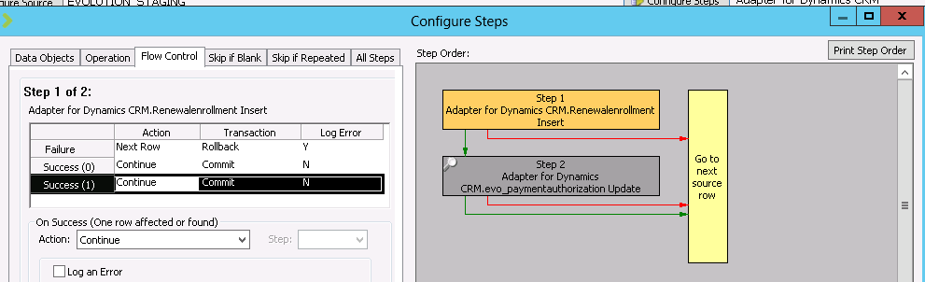

Figure 42: Scribe DTS steps for auto renewal

### Problem Payment

* Payments are handled in ETS. It may happen that certain payments could not be completed.
* Such payments are called problem payments. ETS has the list of these payments.
* ETS send a file to CRM and scribe DTS will update failed payment information of such problem payment.

Below are job details :

|  |  |
| --- | --- |
| Name of job | Frequency |
| ICRM60_PaymentETS_REJ | When file is detected |

As this is the file based scribe , it will be triggered when a file is put on a location.  
Job of scribe is to continuously monitor this location and process the file as soon as it is placed.



Figure 43: Screen shot for file

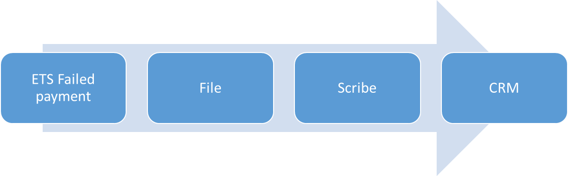

Figure 44:ETS integration via Scribe in CRM

This diagram tells overall flow of failed payment. They are updated in payment authorization entity records in CRM from file given from ETS

# Issues / Constraints

## Issues

* CTI integration will pull the contact record only based on Customer Service Area Zip code. In case of multiple zip codes, the agent has to manually search
* There is supposed to be an integration that allows AWE to import Zip codes, but that’s not working and Zip codes are created manually
* Contractor Rate card entity dictates pricing, but it’s not used
* Ranks are created by Scribe on a quarterly basis. However, the last one was done in July because the one created in October contained a lot of errors
* Rate card entity dictates pricing, but it is not used. They only enter some minimal information
  + Products are then assigned for the rate card, the agreement, the contractor entity itself, and the license manually
  + Pain point as it has to be entered 4 times
  + Even so, agreement and rate card are not being used currently for product association
* Invoice on Claim was supposed to be integrated
* On Payment Authorization, the Next charge date is defaulted to created date. This affects the payment date.
* There is supposed to be a SharePoint Mail merge, to send letters to customers on Problem Payments &Enrollment Cancellation. It’s not working
* Refunding from the Payment Authorization form is not working
* In the Audit records, the last Modified user is not captured as the records are being updated by Scribe and its updated to service account user

## Suggestions

These will be given over time as secondary and primary support continue.

# Application Operations Support

## Production support & Maintenance

The Support tickets are initiated on TFS and then assigned to support team members.

More details will be updated during secondary support.

## Production support parties with contact information

L2/L3 support tasks are yet to be defined. The system is still in Hyper Active Care. Parties involved are listed in the ***Support Activity Roles*** section.

## Production support activities

### Support tasks activity description

L2/L3 support tasks are yet to be defined. The system is still in Hyper Active Care.

### Scope of work for Maintenance & Production Support

Infosys provides development support for the system following the steps on section 8.3.4. AWE does the maintenance of the applications including rollups and hotfixes, as well as infrastructure support.

### Support Activity Roles

Since the implementation is still under Hyper Active Care, the role of Infosys team will be to provide development and implementation support for the implementation.

L2 and L3 will be provided once Steady State is reached, which is expected to happen in Q1 of 2017.

AWE SME Stephanie Carriker is the primary business representative for the project and is part of the governance team.

AWE Joan Haines manages the releases and is part of the governance team.

AWE Darin Ambrose is the SME for integrations.

AWE Mike Pilarczyk is the SME for SQL and integrations.

AWE Stephen Shepard is the SME for architecture and access.

AWE Larissa Luciw is the SME for access to the system.

### Support Methodology

During Hyper Active Care, the following process is followed:

* Business tells their SME about the issue
* The SME works on the issue. If it is determined to be a defect, it goes into Triage.
* The Governance Board decides then on when the defect is assigned to the vendor (Infosys).
* Defects are assigned to a specific bundle. They will be rated on the level of importance and ranked based on priority
* The vendor will then work on the defects, propose a solution, and send the defect back to the SME by assigning the SME to the defect
* The SME would review the fix entered by the vendor on the Fix tab, and approve or disapprove it, depending on the situation.
* If approved, the defect moves from triage to Fixing.
* Infosys fixes the issue, makes the release to test, and changes the status to “in testing”.
* The SMEs will test the fix, and either mark the defect as passing the test or not.
  + If it doesn’t pass, the defect gets assigned back to the vendor.
  + If it passes, this is approved to be moved into production.

Once the application achieves steady state, the idea is to implement a support methodology of L1/L2/l3 support where Infosys will perform L2/L3 support. This process is yet to be defined.

## Application SLAs

### SLA

Application presently in HyperActive care and it is pretty much fix as quickly as possible. More details to be updated during secondary support/primary support phase.

### Tools inventory

#### BI Deployment Tool

##### Overview

This tool is used to deploy Evolution_Staging.dacpac and/or Evolution_Integration.dacpac as well as AWE Integration.ispac is checked-in under “Tools/BI Deploy” folder in environment specific branches (Dev/Main/Prod) within Integration folder.

The Below screenshot mentions the location of BI Deployment tool in TFS.

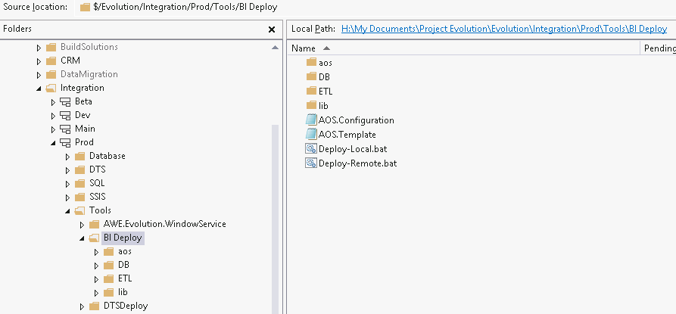

##### Files and Folders

“aos” and “lib” folders are for tools internal use.

“DB”: EVOLUTION_STAGING.dacpac and/or EVOLUTION_Integration.dacpac file(s) which are the compiled output of Evolution_Staging or Evolution_Integration database project(s) are copied to this folder

“ETL”: AWE Integration.ispac file which is the compiled output of SSIS project is copied to this folder

AOS.Template file contains xml, where configurable parameters are set for a particular environment. AOS.Configuration file reads the configuration values from this template file in order to deploy the Evolution_Staging (Database) and AWE Integration (SSIS) Package. Following is the list of parameters the template file has and what they stand for:-

|  |  |
| --- | --- |
| Configuration Key | What it relates to? |
| StagingServer | Server Name where Staging Database has to be deployed |
| StagingDbName | Name of Staging Database which we are trying to create/update with this deployment |
| CrmServer | Server Name where CRM Organization Database exists |
| CrmDbName | Name of CRM Organization Database (Evolution_MSCRM) |
| CRMOrgURL | Organization Service URL for CRM Organization. This can be obtained by navigating to Setting>>Customizations>>Developer Resources within CRM. |
| IntegrationServer | Server Name where Integration Database exists |
| IntegrationDbName | Name of Integration Database (Evolution_Integration) |
| AXServer | Server Name where AX Database exists |
| AXDbName | AX Database Name |
| DtsUser | Username for the account used by Scribe DTS Packages |
| DtsUserPwd | Password for the account used by Scribe DTS Packages |
| Server | Server Name where SSIS Package has to be deployed |
| Environment | Name of the Environment to be created under SSIS |
| FolderName | Name of the SSIS Project to be created under |

The template file with the parameters and its values.

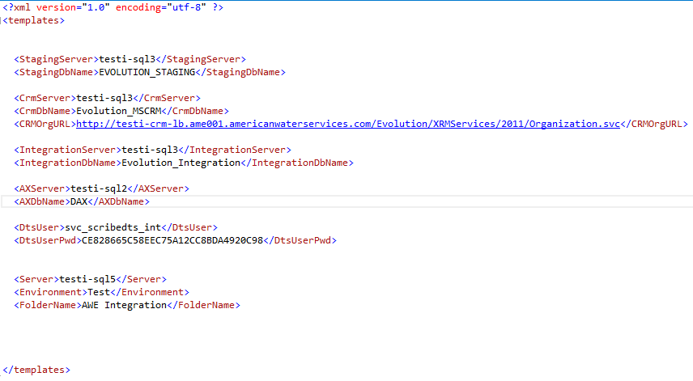

AOS.Template file in the BI Deploy tool under each of the branch (Dev/Main/Prod) contains the parameters already set as needed for deployment to be done in Dev/Test/ Prod Environments respectively.

For Deployment to Test:

The BI Deploy tool is available at C:\Users\Public\Documents\Deploy\BI Deploy folder in Evoscribenp01.

For Deployment to Prod:

The BI Deploy tool is available at C:\Users\Public\Documents\Deploy\BI Deploy folder in AME001-SCRIBE01

#### DTS Deploy Tool

##### Overview

DTS Deploy is a console app that can perform Scribe Deployment related activities like:

* Updating Data Provider and connection details in DTS Package
* Deploying the DTS Package from Source Directory to Target Directory
* Deploying all the Scribe Configuration (.ini/.cfg) files

This is useful while doing deployment as it avoids any manual intervention needed to copy and paste the files and folders and also takes care of all the connection strings being correct and relevant as per the environments need.

The tool is checked in to TFS under specific branches and the configuration file is also up-to-date as needed for deployments to specific environments.

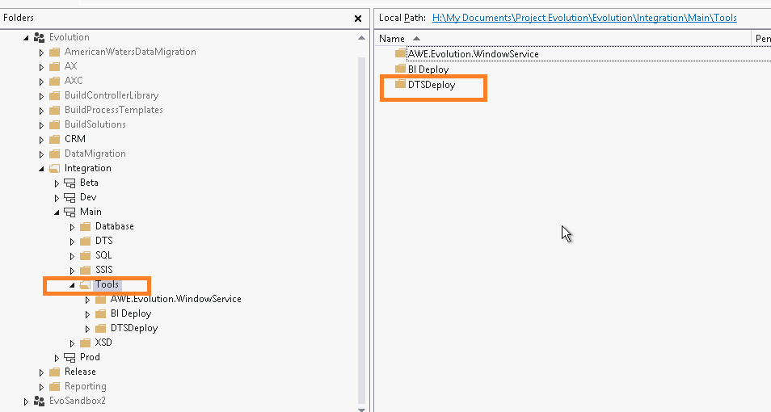

##### Application Settings

Sample App Settings in the configuration file look like:

<appSettings>

<add key="User" value=""/>

<add key="Password" value=""/>

<add key="CrmUrl" value=""/>

<add key="CrmDbConnection" value=""/>

<add key="StagingDbConnection" value=""/>

<add key="CollaborationRoot" value=""/>

<add key="DtsDir" value=""/>

<add key="DeployDir" value=""/>

<add key="DTSConfigSourceDir" value=""/>

<add key="DTSConfigDestDir" value=""/>

<add key="AweI38A_CustomersXsd" value=""/>

<add key="AweI39A_EnrollmentsXsd" value=""/>

<add key="AweI43A_PurchaseOrdersXsd" value=""/>

<add key="AweI44A_ServiceFeeXsd" value=""/>

<add key="AweI87A_VendorsXsd" value=""/>

<add key="AweI37A_RequestRefundUrl" value=""/>

<add key="AweI38A_CustomersUrl" value=""/>

<add key="AweI39A_EnrollmentsUrl" value=""/>

<add key="AweI43A_PurchaseOrdersUrl" value=""/>

<add key="AweI44A_ServiceFeeUrl" value=""/>

<add key="AweI87A_VendorsUrl" value=""/>

</appSettings>

##### Details of Application Settings

Following is the explanation of all the application settings involved in the console application.

**User:**

It is the username of the service account which is used to connect the source and/or destination in the DTS Package. This account should have admin rights on the CRM organization. Note: This account will be different for each environment.

**Password:**

This is a hash password. It is already set correctly in the configuration files in specific environment. For understanding purpose - to get the hash password for scribe account related to a particular environment, open any of the existing DTS package (from the working directory of scribe on the respective environment )in **Scribe DTSEDIT** **Tool**. Following are the respective working directories.

* Test : \\evoscribenp01\c$\Users\Public\Documents\Scribe\Collaborations\Default
* Prod: \\ame001-scribe01\c$\Users\Public\Documents\Scribe\Collaborations\Default

The Scribe dtsedit tool is available under the folder **\Program Files (x86)\Scribe**:

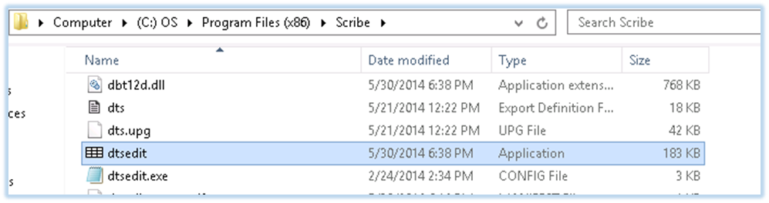

Once you have opened any DTS package with **DTSEdit** on a particular machine, you can just right click on any DTS package and use the “Open-with” option to open the package in **DTSEdit**.

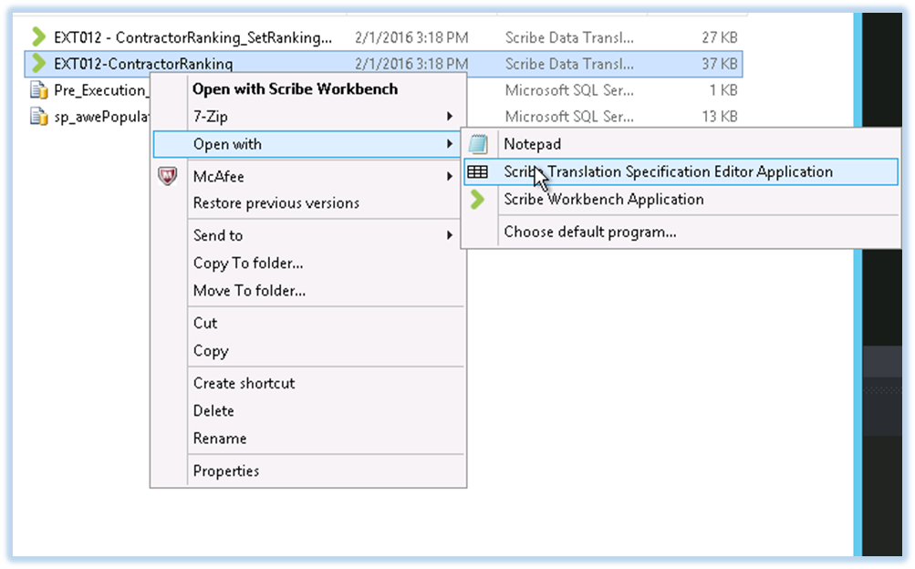

**CrmUrl:**

URL of the Microsoft Dynamics CRM Organization to which our DTS package will connect.

**CrmDbConnection:**

The connection string to point to the Dynamics CRM Database.  
Sample Connection String for CRM Organization on Test Environment looks like-

*Trusted_Connection=Yes;APP=Scribe Insight;WSID=EVOSCRIBENP01;DATABASE=Evolution_MSCRM*

In the above connection string

* WSID is the workstation ID. This is the name of the server on which the Scribe application resides.
* DATABASE parameter accepts the name of the CRM Organization Database

**StagingDbConnection:**

The connection string used to point to the Staging Database.  
Sample Connection String for Staging Database on Test Environment looks like-

*Trusted_Connection=Yes;APP=Scribe Insight;WSID=EVOSCRIBENP01;DATABASE=EVOLUTION_STAGING*

In the above connection string

* WSID is the workstation ID. This is the name of the server on which the Scribe application resides.
* DATABASE parameter accepts the name of the Staging Database

**CollaborationRoot:**

The path of the Scribe “Default” folder under Collaboration.

**DtsDir:**

It is the source folder (extracted from DTS.zip) which contains all the Scribe DTS packages which are to be deployed after their ConnectionString and DataProvider setting are updated.

**DeployDir:**

It is the destination folder where all the Scribe DTS packages from DeployDir (Source location) are to be deployed.

**DTSConfigSourceDir:**

Source Folder within which all the Scribe ODBC Connection Files/Folders are kept.

**DTSConfigDestDir:**

Destination folder where all the Scribe ODBC Connection files are to be updated. In our Environments the path generally is: **D:\Interfaces\CRM** on the same server where the DTS Packages are deployed.

##### AX Specific Configurations-

The following are the 2 types of configuration settings needed specifically for AX:

**Path of the source .XSD file for each interface**

**AweI38A_CustomersXsd**: Path of schema file for the DTS package AweI38A_Customers.dts  
**AweI39A_EnrollmentsXsd**: Path of schema file for the DTS package AweI39A_Enrollments.dts  
**AweI43A_PurchaseOrdersXsd**: Path of schema file for the DTS package AweI43A_PurchaseOrders.dts  
**AweI44A_ServiceFeeXsd**: Path of schema file for the DTS package AweI44A_ServiceFee.dts  
**AweI87A_VendorsXsd**: Path of schema file for the DTS package AweI87A_Vendors.dts

Below is an example of an XSD path:

*C:\Users\Public\Documents\Scribe\Collaborations\Default\****Folder Name\File name.xsd***

Where:

* **Folder Name** is the name of the folder where the DTS package is stored
* **File Name**  is the name of the schema file (.xsd) related to the DTS package

**URL of the Target Web Service for each interface**

**AweI37A_RequestRefundUrl**: URL of web service AweI37A_RequestRefund.

**AweI38A_CustomersUrl**: URL of web service AweI38A_Customers.

**AweI39A_EnrollmentsUrl**: URL of web service AweI39A_Enrollments.

**AweI43A_PurchaseOrdersUrl**: URL of web service AweI43A_PurchaseOrders.

**AweI44A_ServiceFeeUrl**: URL of web service AweI44A_ServiceFee.

**AweI87A_VendorsUrl**: URL of web service AweI87A_Vendors.

Below is an example of an AX web service URL:

*http://ServerName/MicrosoftDynamicsAXAif60/****Port Name in AX****/xppservice.svc*

Where:

* **Server Name**  is the server name of the environment where the web service is hosted
* **Port Name** is the port name of the web service in AX

#### CRM Sync Tool

The CRM Sync tool is a .NET application which helps synchronize records, business units, systemusers, teams, queues, charts, dashboards and reports between two CRM organizations while maintaining the same GUID values within each record.

##### Prerequisites

* Windows Identity Foundation.
* A valid user account with access to the source and destination CRM organizations requiring synchronization.

##### Overview of Synchronization Options

* CRM Solution Import
* Migrate Business Units
  + CopyWithoutUsers
  + CopyWithUsers
  + CopyWithUsersAndSecurityRoles
* Migrate Teams
  + CopyWithoutUsers
  + CopyWithUsers
  + CopyWithUsersAndSecurityRoles
* Migrate AccessTeams
* Migrate Queues
  + Assign with a default Owner (Type “Full Name” of the systemuser)
* Entities to Migrate
  + MatchOnNameOnly
  + MatchOnNameAndID **(RECOMMENDED)**
* SystemUsers
* Charts
  + Selected Users
  + All Users
* Dashboards
  + Selected Users
  + All Users
* Reports
  + Selected Users
  + All Users

Most of the options are self-explanatory, the Business Units / Teams have an option of synchronizing the users and security roles; the Migration of Queues have an optional “default owner” to be assigned to the queues upon creation; Entities can be synchronized by Name only or by both Name and ID (GUID); Charts, Dashboards, and reports can be either all imported or only imported based on the selected system users.

Queue synchronization only works for queues which do not start with the “<” sign since these primarily are internal queues for users and teams. When specifying a “default owner” for the queues, the application will search and match against the system user table by the Full Name. If no “default owner” is specified, the application will attempt to create the queue with the original owner if the owner exists in the destination environment otherwise the default owner will be the user account used to connect to the destination environment.

Entity synchronization will behave differently if choosing to sync by Name only or both Name and ID. Synchronization by Name only will just match the destination environment’s records by Name and if there is no match then it will create a new record. If Matching by Name and ID is selected, then the application will attempt to find records within the destination environment and update labels if the matching records are found by ID (GUID).